PROVISION OF TIER 2
EMERGENCY HORMONAL CONTRACEPTION SERVICE UNDER PATIENT GROUP DIRECTION (PGD)

SERVICE SPECIFICATION
1st April 2017 – 31st March 2020

- Introduction
Pharmacies are well placed to provide swift and easy access to high quality services including some sexual health services and can often be the first point of call for clients seeking Emergency Hormonal Contraception (EHC).

- Aims
- To increase the knowledge, especially among young people, of the availability of emergency contraception and contraception from pharmacies.
- To improve access to emergency contraception and sexual health advice.
- To increase the use of EHC by women who have had unprotected sex and help contribute to the reduction in the number of unplanned pregnancies in the client group.
- To refer clients, especially those from hard to reach groups, into mainstream contraceptive services.
- To increase the knowledge and risk associated with STIs.
- To refer clients who may have been at risk of STIs to an appropriate service.
- To increase access to the diagnosis and treatment of Chlamydia infection.
- To strengthen the local network of contraceptive and sexual health services to help ensure easy and swift access to advice.
- To increase access to free condoms via the local C Card scheme.

- Service Outline
The pharmacy will provide the following service:

- Pharmacists will provide individual information and advice to women seeking emergency contraception. Where appropriate the purpose of the service is to issue EHC – Levonorgestrel 1500mcg or Ulipristal Acetate 30mg – under a Patient Group Direction (PGD) by an accredited pharmacist who has completed the training specified.
- Pharmacists will provide information and advice to women at risk of Chlamydia infection on how to access the on-line screening programme within the target age group, 15 – 24 years.
- Pharmacy staff to provide free condoms to C Card holders (this applies to all C- Card holders not just those seeking EHC).

(See Appendix B for further details on Chlamydia screening and C Card scheme)

The service will be provided in compliance with Fraser guidance and Department of Health guidance on confidential sexual health advice and treatment of young people aged under 16 years.

If a girl under 18 years of age requests emergency contraception, pharmacists must be vigilant of safeguarding issues and follow local Safeguarding Children’s Board guidance. (See Appendix A)

Where the young woman under 18 agrees, an email referral for additional support from the Sex, Teenagers And Relationships (STAR) team can be made direct by emailing STAR@stoke.gov.uk .

The pharmacy must have a standard operating procedure in place for this service. The pharmacy must ensure that pharmacists and staff involved in the provision of this service are aware of and operate within national and locally agreed protocols.

The service can only be provided in an approved pharmacy with a suitable area for consultation with patients. An approved pharmacy is one where the pharmacist has submitted a registration form indicating the full postal address of the premises and confirming the availability of a consultation area that meets the criteria stipulated in the Community Pharmacy Contractual Framework: Advanced Services for Medicines Use Reviews (MURs).

The pharmacy contractor has a duty to ensure that pharmacists and staff involved in the provision of the service have the relevant knowledge and are appropriately trained in the operation of the service.

At the initial request for EHC all clients should be dealt with sensitively and discreetly. Pharmacies will offer a user-friendly, non-judgmental, client-centred and confidential service. Medicine counter staff must refer all such clients to the accredited pharmacist without delay. If an accredited pharmacist is unavailable the client should be advised by the Responsible Pharmacist on duty about the appropriate timescales within which either Levonorgestrel 1500mcg or Ulipristal Acetate 30mg should be taken following unprotected sexual intercourse. The client should also be informed when an accredited pharmacist will be available if appropriate, or where an alternative supply can be obtained (this information should be verified before the client is signposted to another service or pharmacy).

Clients attending when an accredited pharmacist is available should be given access to the service even where this may mean that the consultation is completed after the close of the pharmacy. This should be at the discretion of the pharmacist as they should always ensure the safety of the client, staff and themselves.

The consultation should enable the client to make an informed choice about whether to use emergency contraception, and which method may be most suitable. If appropriate the client should be safely supplied with EHC, Levonorgestrel 1500mcg or Ulipristal Acetate 30mg in line with the PGD.

The client should be made aware of the need to consider long term methods of contraception and the support and follow up that is available to them through the Contraceptive & Sexual Health (CASH) Services, their own GP and the GU Medicine Service.

Whilst there is no limit to the number of times a client can access this service, pharmacists must use their discretion when faced with repeat attendees. It must be stressed to the client that it is an emergency measure only and as above, they should see their GP or the Contraceptive & Sexual Health (CASH) Service to discuss regular methods of contraception.
The pharmacist must personally speak with and counsel the client requesting emergency contraception.

The pharmacist must obtain the information outlined in the proforma before making any recommendations regarding emergency contraception.

EHC can only be supplied in person to the intended user. Friends, relatives or third parties may not collect EHC on behalf of the intended user. If a person requests a supply on behalf of another, the pharmacist should explain that the patient must be seen face-to-face and ensure that they are given appropriate information and advice to pass on to the intended user. Advice may be given over the telephone.

A single pack of the emergency contraceptive pill can be supplied if:

- The pharmacist is satisfied that emergency contraception is appropriate.
- The pharmacist is satisfied that the client understands the circumstances in which emergency contraception will be effective.

The product may only be supplied for use at the time of purchase and should not be supplied for possible future use.

If the client is in agreement, the single tablet dose should be taken at the end of the consultation with the pharmacist. If, after receiving all the necessary information, the client does not wish to take the tablet they should be advised to see their GP or attend a Contraceptive & Sexual Health clinic as an emergency. It should be documented on the proforma that they did not wish to proceed and a claim for the consultation only can still be made.

Advice and information should be given to the client as specified within the PGD.

If the client requires EHC but is excluded from supply under the PGD they should be advised to see their GP or attend a Contraceptive & Sexual Health clinic as an emergency. They should also be offered information and advice on how to access local integrated Contraceptive & Sexual Health Services and their GP practice (a claim can still be made for the consultation only, provided it is documented on the proforma as to why a supply wasn’t made).

3.1 Chlamydia Service

The pharmacist will provide advice about the Chlamydia screening service to all young people aged 15 to 24 years who access the EHC service and signpost as appropriate. (See Appendix B)

3.2 Condom Provision

Stoke-on-Trent City Council strongly encourages Tier 2 pharmacies to be distribution sites for the C-Card condom distribution scheme. This enables pharmacies to provide 13-24 year olds who have registered with the scheme free condoms on presentation of their C-Card. (See Appendix B)

3.3. Population Served

The service is in place for the female population of Stoke-on-Trent, including those who are under 16 years of age, taking into account issues around Fraser competence and Safeguarding. (See Appendix A)

The client must be resident in Stoke-on-Trent and / or registered with a Stoke-on-Trent GP. However, as the efficacy of this drug is time limited, ethically speaking we would not expect the pharmacist to turn anyone away irrespective of postcode.

The pharmacist/pharmacy staff will provide the free condom service to all people who participate in the C Card scheme. (See Appendix B)

3.4. Publicity

Pharmacies should display posters and patient information leaflets promoting the service

3.5 Stoke-on-Trent City Council Responsibilities

Stoke-on-Trent City Council will be responsible for the provision of up to date lists of participating pharmacies that can be distributed to all pharmacies across Stoke-on-Trent.

Staffordshire and Stoke-on-Trent Partnership NHS Trust (SSOTP) will arrange update training sessions to support pharmacists Continuing Professional Development.

SSOTP will provide information on local Integrated Contraception and Sexual Health (CASH) services. Further supplies of CASH leaflets can be ordered from:

Cobridge Community Health Centre 0300 7900 165 or for up to date information visit: www.staffordshireandstokeontrent.nhs.uk/services/cash.htm

Proformas for service specification, PGDs and other related papers can be downloaded from Stoke-on-Trent City Council website www.stoke.gov.uk/pharmacists or requested from the Directorate of Public Health on 01782 234590 or email joy.james@stoke.gov.uk

- Accreditation
The accredited pharmacists delivering the service will have:

- Completed the CPPE distance learning packs on Emergency Hormonal Contraception
- Completed the CPPE distance learning pack on Safeguarding
- Read the PGD for the service
- Completed and signed the PGD declaration, scanned and emailed it to Stoke-on-Trent City Council at: public.health@stoke.gov.uk Mark it FAO Joy James
- Completed the Declaration of Competence on the PharmOutcomes EHC Module
- Read the additional information in Appendix A and B of this service specification and/or have received individual training from a Stoke-on-Trent City Council or an SSOTP representative

Pharmacists providing the service will be expected to attend update training events organised by SSOTP as and when they become available.

- Costs and Monitoring
Each consultation will be refunded at the cost of £14 per client.

Each issuing of Levonorgestrel 1500mcg will be refunded at the current list price of £5.20 plus VAT (5%)

Each issuing of Ulipristal Acetate 30mg will be refunded at the current list price of £16 plus VAT (5%)

Payment will be made quarterly in arrears.

Participating pharmacies will be expected to participate in monitoring and evaluation to show that the aims and objectives of the scheme are being met.

Stoke-on-Trent City Council may ask to see anonymised records of consultations as part of the audit and monitoring process.

- Quality and Verification
The pharmacists will be registered with the General Pharmaceutical Council, based within registered premises and should provide the service in accordance with this service specification.

All pharmacists must email a signed copy of the Patient Group Direction Declaration and have completed the Declaration of Competence on PharmOutcomes prior to making any supplies of Levonorgestrel 1500mcg or Ulipristal Acetate 30mg.

The signed PGD Declarations need to be scanned and emailed to: public.health@stoke.gov.uk or posted to Joy James, Directorate of Public Health, Floor 1 Civic Centre, Glebe Street, Stoke-on-Trent, ST4 1HH.

The pharmacy makes full use of promotional material provided by SSOTP.

The pharmacy reviews its standard operating procedure on an annual basis.

Further quality checks will be made by SSOTP mystery shopping team – a group of young people aged 16 - 18 years and their feedback will be given to each individual pharmacy.

The pharmacy should record the details of the consultation on PharmOutcomes (either live during the consultation or as soon as possible afterwards). All fields should be completed and when the information is saved the system will automatically generate claims for all EHC provisions.The claim run will take place at the end of day on 5th day of the month. If you have problems please check the LPC website for information http://www.northstaffslpc.co.uk/ and if you still have a question or need help with PharmOutcomes contact the LPC (simple issues can usually be resolved locally). PharmOutcomes also has a helpdesk, they can be contacted directly on 01983 216699

The pharmacist should keep patient records and the completed proformas for adults for a period of 10 years after attendance, and for children until the child is 25 years of age. Computerised patient records are recommended.

REPRESENTATIVES
The person set out below is authorised from the Commencement Date to act on behalf of the Authority on all matters relating to this Contract (the Authority Representative)
Name: Jo Bradley
Title: Senior Health Improvement Specialist: High Risk Groups
Telephone: 01782 231807
Email: jo.bradley@stoke.gov.uk

The person set out below is authorised from the Commencement Date to act on behalf of the Provider on all matters relating to this Contract (the Provider Representative)
Name:
Title:
Telephone:
Email:

The Provider may replace the Provider Representative and the Authority may replace the Authority Representative at any time by giving written notice to the other Party
Appendix A

Child Protection

Pharmacists and pharmacy staff regularly come into contact with children and their families in the course of their work and may come across families who are experiencing difficulties in looking after their children. Safeguarding legislation places a statutory duty on organisations and professionals to work together in the interests of vulnerable children. All healthcare professionals, including those who do not have a role specifically related to safeguarding, have a duty to safeguard and support the welfare of children. This means actively promoting the health and well-being of children and also protecting vulnerable children in collaboration with other organisations and authorities.

The changing nature of pharmacy practice means that the profession is likely to have an increased role in safeguarding. As a pharmacist or registered pharmacy technician you may be involved in:

• identifying concerns about a child and referring these concerns to Social Care or the Police
• responding to a request from Social Care for information about a child or their family.
• providing a professional pharmaceutical service to a child or family as part of an agreed child protection plan.

You need to be alert to potential indicators of abuse and neglect, be familiar with local procedures for promoting and safeguarding the welfare of children, and understand the principles of patient confidentiality and information sharing.

All Stoke-on-Trent Policy and Procedures can be found at:

www.safeguardingchildren.stoke.gov.uk

If you have any concerns about the safety or wellbeing of children or if you are uncertain on any issues surrounding sageguarding and need general guidance please contact the Safeguarding Children Team who will give advice to anyone requiring assistance in this matter.

Safeguarding Children Contact numbers:

To make a direct referral:

Safeguarding Referral Team 01782 235100

Emergency Duty Team (after 5pm) 01782 234234

Police Child Abuse Investigation Unit 101

If you think or child or young person is in immediate danger call 999

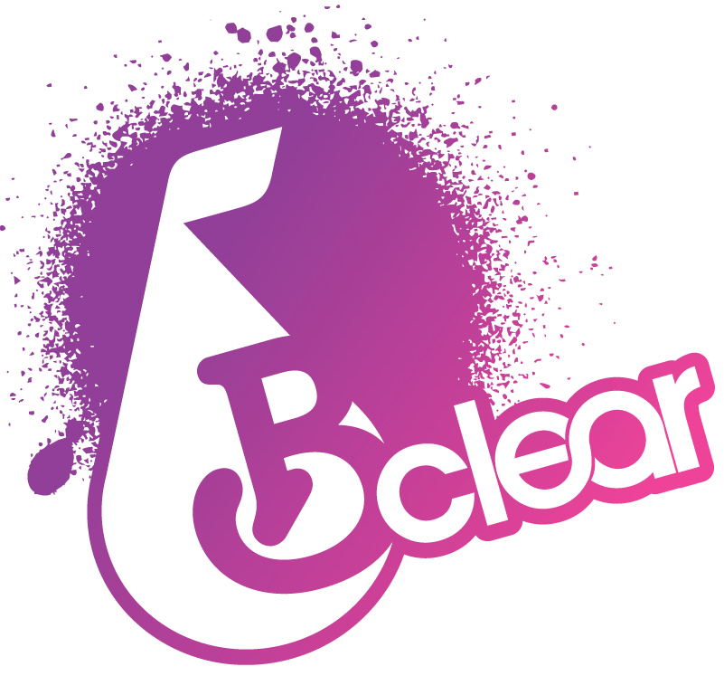
Appendix B

B- clear Chlamydia Screening Programme:

Chlamydia Trachomatis is a bacterial infection; it is the most common sexually transmitted infection of its type in England and Wales. The infection often has no Symptoms.

Untreated genital Chlamydia infection can have serious long term consequences including fertility problems for both men and women.

B-clear is an opportunistic screening programme aimed at young people aged15-24 year old living in Stoke-on-Trent and Staffordshire.

A simple self-taken test and completing a form is all that is required. Clients have a choice of how they receive their test result including text messaging.

Treatment is free to all clients and their contacts.

Young people who are sexually active are encouraged to take the test at least once a year or when they have put themselves at risk of contracting the infection. Risk factors include sex without a condom, change of partners and those who have contracted the infection in the past (evidence shows that positive clients are at high risk of re-infection).

Clients can access screening by:

- Attending Integrated Sexual Health Clinics
- Contraceptive And Sexual Health (CASH) Clinics
- Online postal testing service via web-site: www.b-clear.org.uk
- Schools, Colleges and Universities

Pharmacy can be proactive in promoting the screening programme and signposting young people by:

- Supplying appropriate contact/access details to clients presenting in pharmacy.
- Offering a generic leaflet that gives detail on how to access screening website etc
- Offering Integrated Sexual Health Clinic details/leaflet.
- Offering all clients accessing EHC comprehensive information on the importance of getting tested.
- Having an opportunistic discussion, with clients in the target group (ages 15 to 24 years).

Contact B-clear for further advice/information on 0800 032 0899

The national web-site: www.thisischlamydia.co.uk offers good quality evidence based information that is regularly updated by the National Team.

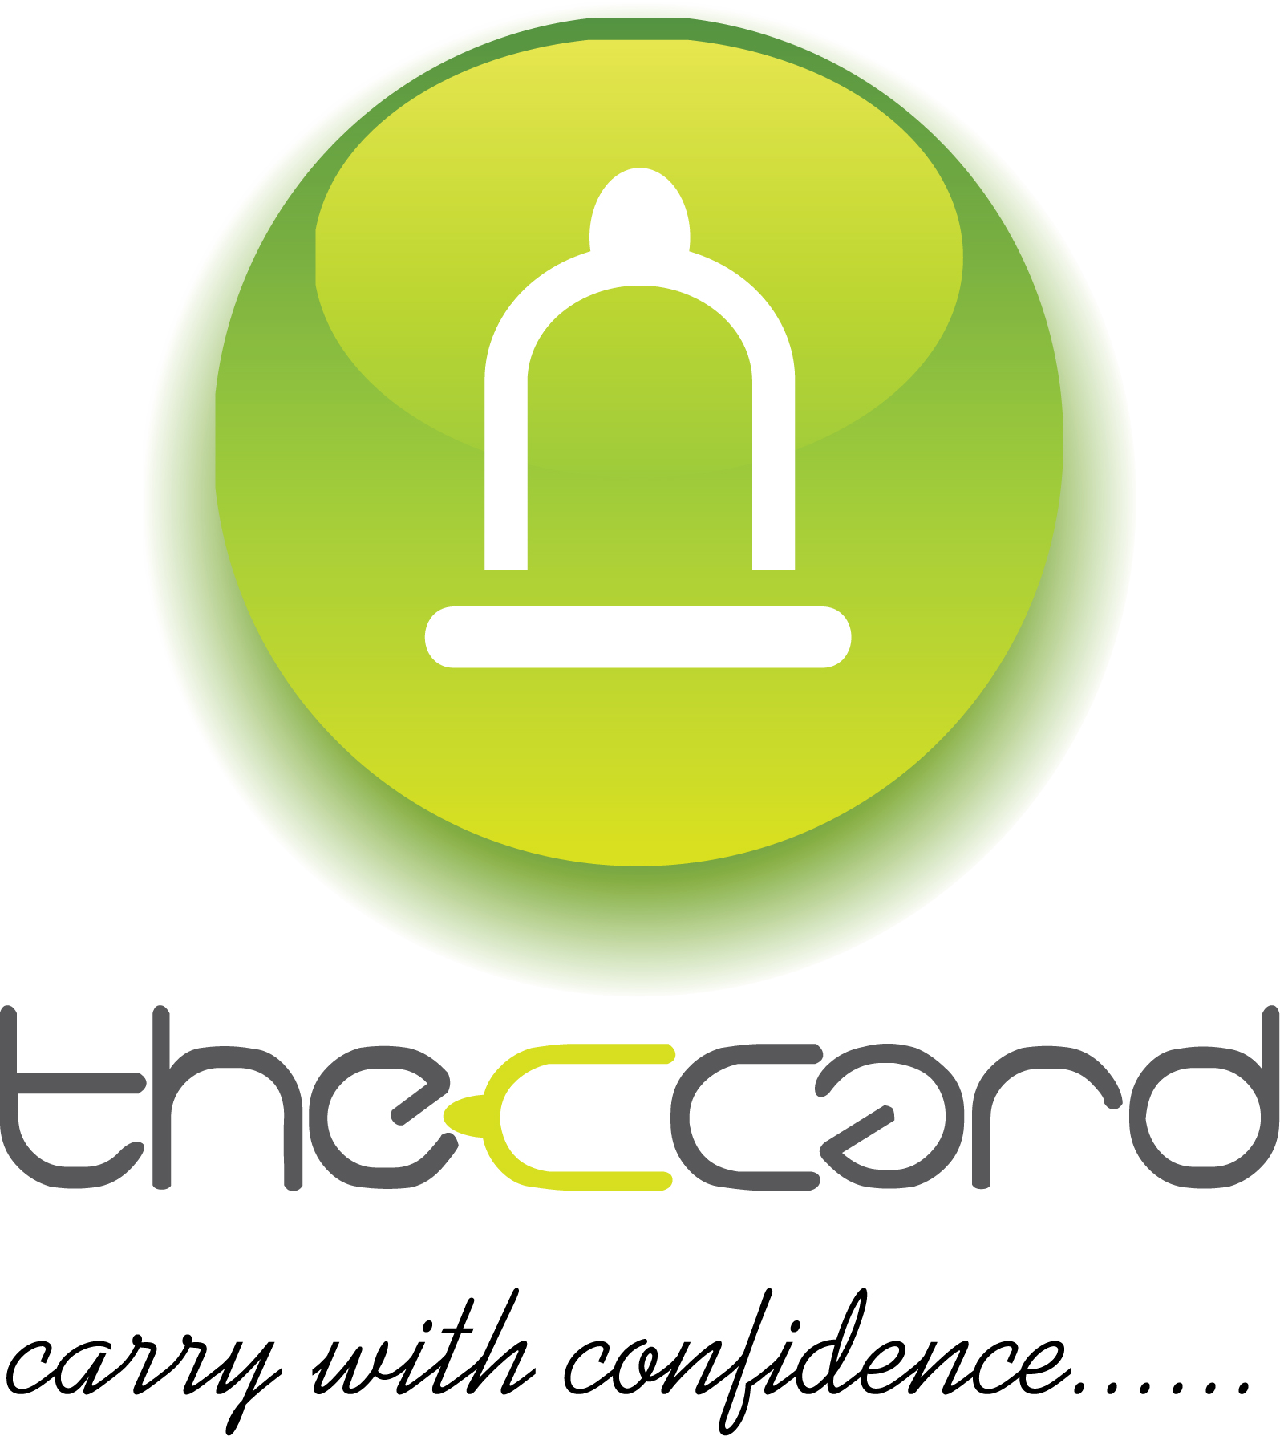
Appendix B contd.

C Card scheme

The C (condom) Card Scheme
The scheme was launched in May 2009. It provides young people aged 13 to 24 and adults from protected groups with additional access to condoms and lubricant in community venues e.g. Pharmacy, GP’s, youth services, colleges, schools and Voluntary Sector. Approximately 20,000 young people across Stoke on Trent and North Staffordshire have registered for a c-card to date.
How do young people get a card?
People can register with any CASH or Integrated Sexual Health Clinic, with an Integrated Sexual Health Team worker, with the Our Health 5-19 team, with the STAR Team or any pre-arranged sexual health event.
When registering for a card
During the registration process the staff member will assess the person’s competency (based on Fraser Guidelines and Mental Capacity Act (MCA)) and go through the process of how to use condoms safely.
The card
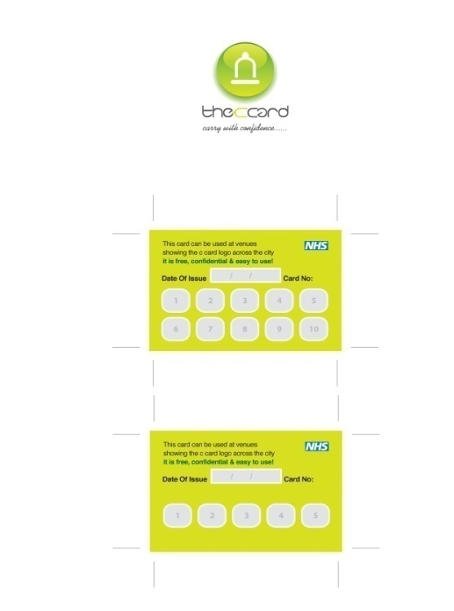
The card does not contain any client identifiable information e.g. name it has a unique c-card number on the back, the clients personal details are held on the secure C-Card database.
How the card works:
On the back of the card there are boxes that relate to the number of visits:
For People under 16 or more vulnerable people there are 5 boxes
For people aged 16+ there are 10 boxes
When the person has reached the maximum number of visits allowed on their card they are advised to go back to a registration site to get a new card. This gives the clinician an opportunity to check in with the person, to see if they have any questions or any further sexual health needs such as screening, a discussion around other forms of contraception etc.
Distribution & monitoring
Once the person has their C-Card they will be able to use it in venues participating in the scheme, identified by posters and window stickers on display. Venues include GP practices, pharmacies, local CASH and sexual health services, Colleges, Schools and many more. A detailed list and to find your nearest distribution venue can be found at www.b-clear.org.uk

Distribution sites collect a limited amount of information:
  - The date of the visit
  - The unique number on the back of the card
  - The number of the visit
At the end of each month the monitoring forms are returned to the C-Card administrator.
Resources offered to distribution sites
Distribution sites are supplied with C-Card literature for display, C-Card packs (made up of condoms, lubricants and information leaflet) and a range of sexual health leaflets, which include information on local sexual health services, positive relationships, contraception and STI’s.
If you would like more information about the C-Card scheme or are interested in becoming a distribution site please contact Charlotte Smith on 0300 123 0995 ext: 3316 or email charlotte.smith@ssotp.nhs.uk

