Important information about the EPS Release 2 Phase 4 Pilots
This briefing provides pharmacy teams with information about the next phase of EPS (called ‘Phase 4’) - this is the point at which electronic rather than paper prescriptions become the default. We will test this initially in a small number of pilot GP practices soon.
EPS Phase 4
Currently patients need a nomination to use EPS but the next phase of EPS will mean that the majority of prescriptions will be signed and sent electronically, even for patients who don’t have a nomination. Over 19 million patients already have a nomination and nothing will change for them. All existing nominations will remain valid and further nominations for appropriate patients should continue to be set. You don’t need to do anything with those nominations already set.
Patient presenting non-nominated token
Patients without a nomination will be given a paper token by their GP practice (Patients may refer to these as “paper copies” of their prescription).
All pharmacies will need to be ready and know what to do should a patient present a token in your pharmacy. Remember patients can take their token to any pharmacy in England.
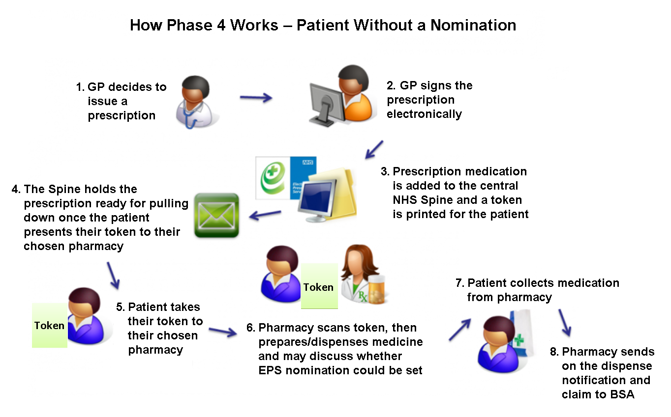
- You will need to scan the unique barcode on the token or enter the barcode number to retrieve the prescription as these will not come through on your bulk downloads (overnight or manual).
- A token won’t be hand signed by a prescriber because the prescription will have been signed electronically, in the same way as nominated prescriptions are now.
- The legal prescription is the electronic prescription, so you should always scan the token to get the legal prescription before dispensing to ensure that the prescription is still valid.
- You will need to send dispense and reimbursement notifications for these prescriptions in the same way as you do for nominated prescriptions now.
- Only items that are non-compliant (for example items which are not listed in the NHS drug database, dm+d) will be printed on a paper FP10 and hand-signed by the prescriber.
For patients that are part of a Prescription Collection Service but don’t have a nomination, a token will be printed (instead of an FP10) for the pharmacy to collect.

If your local GP Practice is taking part in the pilot
If you are a pharmacy that currently receives many prescriptions from one of the pilot GP practices there will be factsheets available and animation videos to explain the process. We will be contacting you directly with more information. Pharmacies affected by the pilot will be processing a larger volume of electronic prescriptions.
Encouraging your patients to set a nomination
Many of the EPS benefits are associated with nomination, therefore when EPS progresses to Phase 4, it is important that appropriate patients continue to be given the opportunity to benefit from using nomination.
You may want to encourage more of your patients to set up a nomination if they:
- obtain regular prescriptions
- use your pharmacy every time
- are already using your Prescription Collection Service

Patient consent is still required for nomination and it’s up to the patient to decide to nominate or not. Patients can only nominate one pharmacy at a time and they can change or remove it whenever they like.

Patients who receive medication and appliances can set one nomination for a pharmacy and another one for their dispensing appliance contractor (DAC) where appropriate.

Once a patient has a nomination in place, if they receive repeat prescriptions, they won’t need to visit the GP practice to collect a token, because the prescription will have already been sent electronically to their nominated pharmacy.

Frequently asked questions
Q. What needs to happen before the full deployment of Phase 4?
A. HSCIC recognises that full deployment of Phase 4 will significantly increase the volume of electronic prescriptions and it is vital that all elements of the service are robust. There are key items that need to be completed prior to full deployment such as being able to prescribe and dispense Schedule 2 and 3 Controlled drugs via EPS Release 2. HSCIC is also working with system suppliers and others to improve business continuity to ensure minimal impact of potential system issues or failure.
Due to external dependencies we are unable to state a specific date for full deployment of Phase 4, but key items will be completed before a date will be confirmed.
Q. Can I endorse non-nominated tokens?
A. As with all EPS prescriptions, endorsements need to be made onto the electronic prescription using your PMR system. Endorsements written or printed onto any type of EPS token will not be processed by the NHS Business Services Authority (NHSBSA).
For more information about the future of the Electronic Prescription Service
There is more information available on the EPS Website: http://systems.hscic.gov.uk/eps/future-eps and on the PSNC website: http://psnc.org.uk/phase4. We will publish the small list of pilot GP Practices on the EPS and PSNC websites shortly. As explained above pharmacies who receive many prescriptions from GP practices will be contacted directly.

