North Midlands – Shropshire & Staffordshire Area
Anglesey House
Towers Plaza
Wheelhouse Road
Rugeley
WS15 1UL
Date: 09th February 2018
Email – a.pickard@nhs.net

Dear Colleague,

Re: Stay Well Pharmacy Campaign

I am pleased to announce details of the next public health campaign which is a national campaign delivered by NHS England. The campaign will be targeting parents or carers of children aged five years or under, aiming to increase their confidence and trust in the advice given by community pharmacy teams, and encourage them to use pharmacies rather than visiting their GP for minor health concerns.

The campaign will launch on 12th February and will run until 31st March.

This campaign builds on the Stay Well This Winter campaign, with the primary aim to increase the use of community pharmacy services for clinical advice and self-care and to reduce the number of appointments with General Practitioners that can be effectively managed with clinical advice from a pharmacist or pharmacy technician.

The campaign is being supported nationally through;
- Television advertising;
- Social media activity;
- Posters and leaflets; and
- A media partnership with NetMums

Resources

Campaign materials are being delivered directly to all community pharmacies in the form of a toolkit that includes posters, leaflets, and shelf wobblers. These toolkits will be arriving in your pharmacies from Monday 12th February, and are being distributed centrally by NHS England. Therefore if you have not received a toolkit by Wednesday 14th February, can you please let me know as I will need to feed this back to the national team.

Data collection and PharmOutcomes

As a reminder, it is a contractual requirement for the information to be transferred from the data collection sheet onto the relevant campaign module on PharmOutcomes within 7 days of the end of each campaign please. Failure to do so may result in a breach notice being issued.

If you have any queries regarding this campaign or access to resources please contact me via email, or speak to one of your LPC representatives.

Yours faithfully,
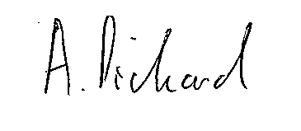
Andrew Pickard
Pharmacy Advisor, NHS England North Midlands, Staffordshire and Shropshire Area

