*On 4 February, NHS England will launching a ‘Pharmacy Advice’ campaign under the overarching brand ‘Help Us Help You’. The aim of the campaign is to encourage the public to use their local pharmacy as their first choice of healthcare setting for clinical advice for minor health concerns such as coughs, colds, tummy troubles and aches and pains. The campaign will help to further build the public’s trust and confidence in community pharmacists and the pharmacy team as providers of care, and ensure minor illnesses are effectively managed in the right place.*

*A printed set of branded resources will be sent to all community pharmacies in England, with delivery being made week commencing 28 January 2019. The outer packaging will be clearly labelled with a green, NHS branded sticker:*

*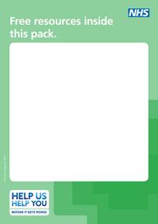*

*The pack will include a double-sided window sticker, wobblers, poster, information cards and a dispenser.*

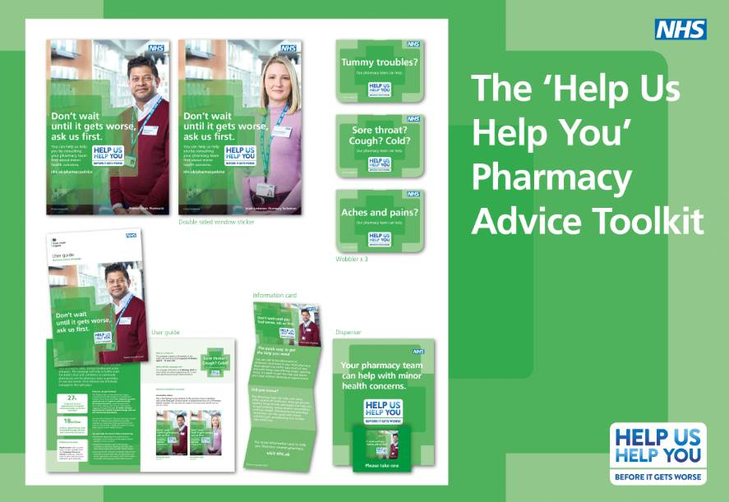

*The NHS would encourage you to make the most of these resource by:*

* *Prominently displaying the materials in your pharmacy, in the window and alongside relevant over-the-counter products*
* *Using the information card to remind your customers to visit your pharmacy next time they need clinical advice about a minor health concern*
* *Ensuring all staff members are briefed ahead of the campaign to ensure that they are fully aware and, where appropriate, are ready to offer clinical advice for people with everyday minor health concerns.*

*There are a range of additional free resources available to order or download. This includes digital screen content and social media assets. To access these resources and register for regular updates on campaigns, visit the Campaign Resource Centre at: campaignresources.phe.gov.uk*

*If you have any queries about the campaign, please contact:* [*partnerships@phe.gov.uk*](mailto:partnerships@phe.gov.uk)