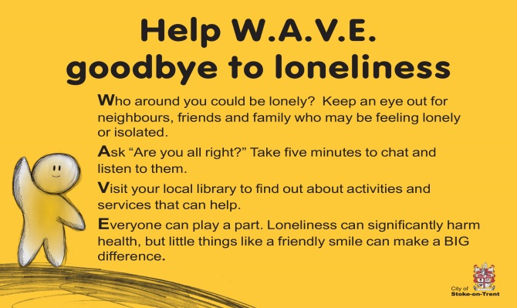

**Loneliness and Social Isolation Campaign**

**Briefing note**

Tackling loneliness and isolation is a key priority for Stoke on Trent City Council, the Loneliness Strategic Partnership and the Age Friendly City movement. Loneliness can affect people of any age but the factors that increase the risk of loneliness and social isolation increase with age making loneliness a serious issue for older people with over 1 million people over 65 in the UK report feeling often or always lonely.

Loneliness is an individual experience when the number of or quality of relationships is less than they would like so it can be the loss of an important relationship with one person (such as in bereavement) or the lack of a wider circle of friends or social network. Social Isolation is different in that it results from an imposed isolation from social networks due to mobility, transport or poor health.

**Business objective**

This campaign is one of the actions decided by the Loneliness Strategy Group and is one of a number of actions aimed at reducing loneliness and isolation in the city. The aim of the campaign is to promote the involvement of whole communities in reducing isolation and loneliness. It looks to raise awareness that loneliness and isolation is preventable and encourage people to take action. It seeks to do this by:

1. Destigmatising loneliness and isolation – get people talking about it across the city,

2. Raising awareness that loneliness and isolation can affect a wide range of people – not just older people

3. Building on the reputation of Stoke-on-Trent as a friendly City – encourage everyone to take small steps that can help reduce loneliness and isolation.

**Campaign objectives:**

1. To raise awareness of the issue of loneliness and isolation across the City, who can be affected and how to recognise it.
2. To encourage people to act – everyone has a role in preventing and tackling loneliness, ensuring people know what they can do and what is available for support/signposting.

**Target audience – everyone who comes into contact with those at risk of loneliness and social isolation - through friends, family, work or where they live.**

Groups identified as being at higher risk:

* Older people
* People with disabilities or long term health conditions
* Carers & Young Carers
* Refugees, Homeless, Ex-offenders
* Children & parents
* Men
* LGBT
* Young people leaving care

**Key messages:**

Let’s **Wave** goodbye to Loneliness

**W**ho around you could be lonely?  Keep an eye out for neighbours, friends and family who may be feeling lonely or isolated.

**A**sk – “Are you alright?” Take five minutes to chat and listen to them.

**V**isit your local library to find out more about activities and services that can help

**E**veryone can play a part – Loneliness can significantly harm health, but little things can make a BIG difference (link to top tips/Random Acts of Kindness suggestions)

We’re a friendly city – let’s prove it! 🖐

**The campaign aims to change people’s perceptions about loneliness and reduce the stigma associated with it and challenge people to prove that we are the friendly city**

The role you and your organisation can play:

* Libraries were identified as a main hub for people to come and gather/ask about information should they be feeling lonely or know/care for someone who is feeling lonely – can you direct people to their local library?
* Please spread the word about this campaign – retweet the City Council media – use the artwork attached – contact me if you need artwork in a different format
* Can you signpost people to activities in your local area? Maybe have a 5 minute chat to find out their interests?
* Can you signpost people to activities across the City that you know of?
* Can you signpost them to professional services such as the Carelink befriending scheme? I’ve attached some info about partner activities as a starter for ten but please feel free to build on this as you gather information about activities/services across your area.
* Could you print out copies of the attached Random Acts of Kindness (RAK) to make available to everyone coming into your organisation?
* Could you make people aware of the Blue Iris campaign and how they can get involved in that? [www.stand-stoke.org.uk](http://www.stand-stoke.org.uk)

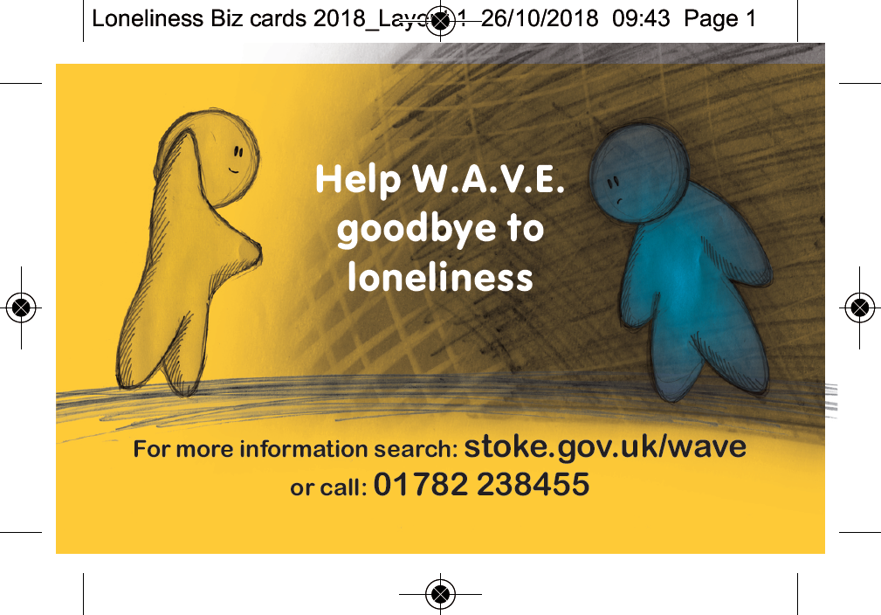



Contact [Alexandra.Nisbeck@stoke.gov.uk](mailto:Alexandra.Nisbeck@stoke.gov.uk)

01782 232349

Help W.A.V.E.

**Partners who sit on the Loneliness Strategic Partnership:**

1000 Lives

Age UK North Staffs

Beth Johnson Foundation

My Community Matters

Rideout

Saltbox

Staffordshire Housing Group

Stoke Live at Home Scheme North

STAND (Stoke-on-Trent Area Network for Disability) incorporating the Blue Iris Project

Vintage Volunteers

Staffordshire Police

Staffordshire Fire and Rescue

Workers Education Authority (WEA)

Places of Welcome

Father Hudson’s

Contact the Elderly

**Council departments:**

Public Health

Adult Social Care

Trading Standards

Local Matters

Stoke-on-Trent Library Services

City Intelligence Unit

**Random Acts of Kindness – Could you do one a day?**

**Loneliness and Social Isolation Media Campaign 2018**

* Call a friend you haven’t spoken to in a while
* Have a clear out and take items to charity a charity shop
* Smile and say hello to people you may pass every day but have never spoken to before
* Make someone a cup of tea
* Offer to baby sit for a friend
* Let someone jump the queue at the supermarket
* Give up your seat for someone that needs it
* Offer to pick up a friend or family member from work
* Listen to somebody who is having a bad day
* Tell your family you love them
* Donate to charity
* Let someone know you’re proud of them
* Leave a surprise note or drawing on someone’s desk
* Spend time playing with your pet
* Praise someone for something they have done well
* If it’s raining lend someone your umbrella
* Cook a dish for someone else
* Help an elderly neighbour take the bins out
* Let a car go in front of you, particularly on a busy road
* Pass a good book on when you’ve finished with it
* Sign up to the organ donor register
* Sign up to give blood
* Take time to yourself when you’re feeling stressed – go for a short walk or a coffee
* Clean the communal refrigerator, microwave or oven in your workplace
* Hold the door open for those behind you
* Bring treats in for your colleagues
* Donate coats and blankets to a homeless shelter, particularly in winter.
* Donate creative items, toys or games to a children’s hospital
* Say thank you more
* Borrow or hire products you only use occasionally
* Smile at a stranger
* Put your loose change in a charity box
* Feed ducks in the park
* Turn the lights off when you leave a room

**Top Tips**

* Start slowly
* Join the Blue Iris project - talk to people when you are out and about on the bus, shopping etc as long as it’s safe to do so!)
* Phone/facetime a friend or family member you haven’t spoken to for a while
* Join a group
* Take up a new interest or hobby – focusing on an activity often makes it easier to talk to new people.
* Volunteer to do something you enjoy or are passionate about
* Smile and say hello to people
* Get out for a walk
* Join a safe online support community to keep yourself safe online and elsewhere [www.elefriends.org.uk](http://www.elefriends.org.uk) (run by MIND) [www.scdas.org.uk](http://www.scdas.org.uk) (Stoke on Trent Community Drug and Alcohol Services) [www.supportstaffordshire.org.uk](http://www.supportstaffordshire.org.uk) (Adult safeguarding board) [www.staffsscb.ork.uk](http://www.staffsscb.ork.uk) (children’s safeguarding board) [www.citizensadvice.org.uk/consumer](http://www.citizensadvice.org.uk/consumer) (trading standards) [www.actionfraud.police.uk](http://www.actionfraud.police.uk) (fraud)[www.friendsagainstscams.org.uk](http://www.friendsagainstscams.org.uk) (scam prevention) [www.thinkjessica.com](http://www.thinkjessica.com) (scam prevention)
* Don’t be afraid to ask for help – Loneliness can affect us all at some time in our lives:
* Visit your local library to find out about local activities and services that can help
* Call Carelink for telephone befriending (for the over 50s) 01782 810320