Department of Health and Social Care (DHSC) COVID-19 Response

National Testing Programme

Clinical Standard Operating Procedure (SOP) for Mass Testing with Lateral Flow Antigen Testing Devices

Version 2.8

Date of publication: 16/12/2020

Master SOP Template Authorised by: Dr Tom Fowler and Dr Peter Marks, National Testing Programme Health Protection and Public Health Leads

[TEXT BELOW TO BE INSERTED BY USE CASE TEAMS ON ALL PILOT SOPs REPLACING AUTHORISATION STATEMENT ABOVE]
[This Pilot SOP is based on a variation of the Clinical Standard Operating Procedures (SOP). The Use Case team is accountable for obtaining approval for all clinical changes]
Contents

- Introduction 9
  - How to use this document 10
- Clinical Governance 10
  - Clinical governance framework 10
  - Risk and incident management 11
  - Safe care and treatment 11
  - Premises and equipment 12
  - Staffing 12
  - Need for consent 12
  - Service improvement and learning 12
- Public Health Aims and Evaluation 12
- Testing Technology 13
  - Lateral Flow Antigen test 13
    - How the test works 13
    - Product specifics 14
    - Implication of LFD results 14
    - Instructions for use (IFU) 14
- Key Stakeholders 14
- Site Set-up 16
  - General site set-up 16
  - Testing site set-up: 19
  - Set-up for analysis: 20
- Testing Process 20
  - Eligibility 21
  - Registration 21
  - Face coverings 21
  - Sample collection and analysis overview 22
  - Detailed testing process 23
    - Self-swabbing sample collection procedure: 23
    - Sample processing and analysis procedure 24
    - Reading and interpreting LFD result 25
    - Recording of results 27
    - Communication of results 28
    - Reporting 28
    - Negative results 29
    - Invalid results 29
    - Positive results 29
    - Travel advice for positive results 30
    - Repeat testing 30
  - Quality management 31
    - Internal Quality Assurance 31
    - On-going programme-level evaluation 31
    - Site level quality management plan 31
    - Accountability 32
- PPE 33
- Supply & Equipment 34
- Data Management 34
  - Data control 34
  - Consent from the data subject 35
- Appendix A: Infection Prevention and Control (IPC) 36
  - General guidance 36
  - Cleaning policy 36
  - Hand sanitisation 38
- Appendix B: Waste Management 38
  - Classification 38
  - Regulatory Position Statement C23 38
  - Prior to a new site being set up 38
  - Waste produced from testing sites 39
  - Transportation category 39
  - Waste bags 39
  - Storage: 72 hours storage and reclassification is not acceptable 39
  - Waste streams for Asymptomatic Testing Site - Lateral Flow Testing 40
- Appendix C: Site Layout 42
  - Booth layout 42
    - Single booth layout 42
    - Multi-booth layout 43
    - Booth layout: further requirements 43
  - Open plan layout 44
    - Single open plan layout 44
    - Multi-open plan layout 45
    - Multi-open plan layout with partitions 45
    - Open plan: further requirements 45
  - Organisations to build their own site 46
- Appendix D: Self-swabbing Instructions 47
- Appendix E: PPE instructions – putting on and taking off 48

Document Control and Approval
Version Control
The table below contains a summary of the most recent version.
For additional version control please refer to the embedded XLS.
Version | Author | Summary of Changes | Reviewed By | Date
2.7 | PHCO | - Clarification on cover page that only Master SOP is authorised by NTP Health Protection and Public Leads. Pilots should be based on a variation of the Template  - LFD scope summary updated with guidance notes. Each pilot is required to tailor this for their specific application  - Care Quality Commission registration advice has been updated  - Result reporting updated with further detail on amendment to the Health Protection Regulations relating to notifiable diseases reporting  - Minor changes to negative and invalid results based on latest SMS notification  - New section on repeat testing, including guidance on where subject has tested positive within 90 days  - Quality management section includes updated text on IQA and programme-level evaluation  - Waste management section revised to include greater detail in line with National policy. Please note that this guidance will need to be reviewed by the relevant agencies in Devolved Authorities for local application. | Tom Fowler / Peter Marks / Suzanne Morris | 09/12/2020
2.8 | PHCO | - Updated information relating to changes in law. Pilots are not required to register with the CQC or receive UKAS accreditation  - Updated information related to testing children under the age of 18  - Updated information to the length of time people living with a positive subject should self-isolate following a positive LFD result  - Clarification of the level at which analysis will be done for ongoing evaluation of quality management  - Addition of a table summarising Waste Management processes  - Addition of an example for ATS layout (multi open plan layout with partitions) | Tom Fowler / Peter Marks / Suzanne Morris | 16/12/2020

Approval
Cell Name / Role | Review / Approval | Version Reviewed / Approved | Date
Testing Programme / Deputy Director, Delivery Integration | Approval | 1.0 | 20201023
Clinical / Public Health | Approval | 1.2 | 20201027
Testing Programme / Deputy Director, Delivery Integration | Approval | 1.3 | 20201027
Testing Programme / Deputy Director, Delivery Integration | Approval | 1.9 | 20201103
Testing Programme / Deputy Director, Delivery Integration | Approval | 2.0 | 20201105
Testing Programme / Deputy Director, Delivery Integration | Approval | 2.3 | 20201110
National Testing Programme Health Protection and Public Health Leads | Approval | 2.4 | 20201118
National Testing Programme Health Protection and Public Health Leads | Approval | 2.5 | 20201125
National Testing Programme Health Protection and Public Health Leads | Approval | 2.6 | 20201202
National Testing Programme Health Protection and Public Health Leads | Approval | 2.7 | 20201208
National Testing Programme Health Protection and Public Health Leads | Approval | 2.8 | 20201216

Lateral Flow Device SOP Scope Summary
[All Pilots are expected to update this section appropriately]
Use Case:
Pilot Institution:

1. Public health aim
Please speak to your PHCO liaison to define what your public health aim is. As a general rule, most pilots are active case finding, but there have been some surveillance cases as well | Click the relevant box below to mark with an ‘X’
Active Case Finding  ‘Identifying positive cases of COVID-19 within the population, and ensuring they self-isolate to reduce transmission to other people; this could include regular testing of the contacts of a case’ | ☐
Surveillance  ‘Finding out the incidence and prevalence of COVID-19 in the population, and changes to these over time’ | ☐
[Additional Public Health aims can be added to this box, if applicable, please speak to PHCO] | ☐

2. Testing frequency
Frequency of Testing  (per individual within population) | ___ tests per  [day / week / month / other: ____ delete as appropriate]

3. Pilot includes a research study?
If you believe there is a research component required to your study, please liaise with Sarah Tunkel (Sarah.Tunkel@dhsc.gov.uk) to discuss research requirements including ethics approval
Click the relevant box below to mark with an ‘X’
☐ No ☐ Yes, ethics approval granted ☐ Yes, ethics approval required

4. Lateral Flow Device
At the time of writing this document, only the Innova SARS-Cov-2 Antigen Test feature in this SOP, once additional devices are approved for pilots they will be updated into the SOP
Innova SARS-CoV-2 Antigen Test IFU | ☒
SD Biosensor Saliva IFU, SD Biosensor Swab IFU | ☐
Abbott Panbio COVID-19 Ag Rapid Test Device | ☐
OrientGene Coronavirus Ag Rapid Test | ☐

5. Situation in which LFD will be used
Pilot – DHSC clinical responsibility | ☐
Pilot – external clinical responsibility | ☐
Post-Pilot Roll Out – DHSC clinical responsibility | ☐
Post-Pilot Roll Out – external clinical responsibility | ☐

6. Population tested
This document has been written on the basis for asymptomatic testing only
Click the relevant box below to mark with an ‘x’
☐ Symptomatic ☒ Asymptomatic

7. Sample type
Throat and Mid-turbinate Nose Swab (where possible) | ☒
Throat Swab only | ☐
Nasal (mid-turbinate) Swab only | ☐
Nasal (double anterior nares) Swab only | ☐
Saliva | ☐
8. Sample collection method
☐ Assisted ☒ Self-implemented
9. Sample preparation, application to LFD and results interpretation
At the time of writing this document, sample preparation, application to LFD and Results Interpretation was only approved to be done by trained staff, not by the Subject themselves
☒ Assisted ☐ Self-implemented

Pilot end-to-end process and accountable organisation
Pilots should update this section appropriately and maintain for their records.
Area | Processes | Accountable Organisation | Authorised Signature | Date
Governance | Clinical accountability
Evaluation | Evaluation framework creation
 | Evaluation data collection
 | Evaluation data analysis and write up
Workforce | Training
 | Pilot Set-up
 | Pilot Delivery (swabbing)
 | Pilot Delivery (LFD Processing)
Operations and Logistics | Supplies: consumables
 | Supplies: test kits
 | Site set-up (general testing and analysis)
 | Waste management
Testing process | Identification and recruitment of people to test
 | Registration of participants
 | Sample collection
 | Sample processing
 | Results analysis
Incidents and Queries | Results notification
 | Response to queries from people tested
 | Risk and incidence management
 | Media queries
Quality assurance | Quality assurance: operational delivery
 | Quality assurance: data analysis and reporting

- Introduction
[This template should be tailored for use in individual pilots]
This document is a template for the standard operating procedure (SOP) for mass testing for COVID-19 using lateral flow technology. This testing framework has been provided by the Department of Health and Social Care (DHSC), delivered through partnerships with a number of private and public sector organisations and the Devolved Administrations.
The contents of this document were accurate at the time of publication, however are subject to change based on learnings from pilots and policies of the National Testing Programme. This document is not considered to be final and is not yet fit-for-purpose for scaling LFD devices. Pilots are expected to incorporate material updates to this document into their operations as the Master SOP is updated.
It is expected that pilot clinical SOPs may need to rapidly iterate in light of local delivery aims and circumstances. Where DHSC is responsible for or has oversight of delivery and pilots clinical SOPs deviate substantially it is expected these deviations will be flagged to clinical and public health leads for additional sign off. Where there is local responsibility or oversight of delivery sign off for tailored pilot clinical SOPs is local. Clear accountability for different aspects of a pilot should be agreed and documented before commencement.
This document describes the appropriate clinical governance and infection control for sampling and testing procedures at asymptomatic testing sites (ATS), responsibilities of site staff, how to conduct interactions with people being tested, and clinical data management principles.
The target for this service is asymptomatic testing. The tests described in this document are designed to enable collection of a throat and nasal swab, which is analysed on at the testing location (not a laboratory) to detect the presence of the virus that causes COVID-19.
This document describes the appropriate clinical and infection control for procedures for the Innova SARS-Cov-2 Antigen test, responsibilities of site staff roles interacting with Subjects and the clinical data management principles. As other devices or products are introduced across the network, the details e.g. IFU, will be incorporated into the SOP.
ATS sites currently only offer tests where the test processing is conducted by a trained member of staff, however this SOP is designed to introduce the format where the end-to-end process is conducted by the Subject. The requirement for this will involve additional approvals over and above those currently covered in this document.
The primary audience for this document is clinical and public health review and all those with a clinical and public health interest in the testing. This document will be shared with key program stakeholders including the NHS, Public Health bodies, Local Resilience Forums (LRF) and the Devolved Administrations. These clinical SOP are designed for safe implementation of approved processes, Major changes or innovations to these SOP must pass through the same approval process before implementation.
Pilots that are planned in devolved administrations must have the clinical SOP reviewed and agreed by the devolved administration. This can done via the Devolved Administration engagement for testing team.
The law has now changed which makes COVID-19 an activity that falls outside the scope of registration with the Care Quality Commission (CQC). It is therefore not a requirement for pilot studies of Use Cases to register with the CQC to provide COVID-19 diagnostic and screening services. UK Accreditation Service (UKAS) accreditation is not mandatory so long as the provider is not selling their test kits or services. It is still recommended that providers seek UKAS accreditation under the new adapted UKAS 3-stage accreditation scheme created for them to gain this at a quicker speed.
For pilots where DHSC does not have clinical responsibility, this document should be used as a guidance.

How to use this document
This document should be used as a template for the pilot SOP and should be used as described below:
- Create a v0.1 of the pilot SOP based on this template (do not make a new version of this template SOP)
- Track changes for all adaptations required for the pilot delivery
- Seek input from the Operations team on changes of an operational nature
- Get clinical/public health review and approval (where a DHSC run pilot)
- Clinical Governance

Clinical governance framework
[Pilots should define here their clinical governance, clear end-to-end process and accountabilities (guidance below)]
Clinical governance is the mechanism through which healthcare services are held accountable for continuously improving their quality safeguarding high standards of care by creating an environment in which excellence in clinical care will flourish. Effective clinical governance ensures that risks are mitigated, adverse events are rapidly detected and investigated openly, and lessons are learned. It is an umbrella term for a framework of activities that help sustain and improve high standards of clinical care.
Effective clinical governance requires:
- A supportive environment and organisational culture that recognises the importance of good clinical governance
- Effective systems, processes and information flows to assess, monitor and improve the quality and safety of services provided, including application of evidence-based practice
- Sufficient numbers of suitably qualified, competent and experienced staff to deliver care to the required standard
- Risk and incident management systems setting out the management of safety concerns, safety incidents and risk mitigation
In addition, rigorous audit will help reduce the risk of errors and where this occurs it will help identify them quickly and manage them effectively and sensitively.
There are a number of clinical elements to services delivered in both the current and emerging Test and Trace structure, some of which are very new and developing and others which are existing organisations and have established clinical governance frameworks in place. Effective clinical governance must be in place to ensure that there is a consistent approach to quality and safety of clinical services delivered across the totality of the programme.
It is required that a clear end-to-end description should be in place to ensure people and organisations managing the testing have clear accountabilities and handover points. The process flow should include organisations and roles for clarity. Pilots should ensure they have documented agreement of the model.
Due to downstream implications for the local public health response, each pilot should engage with the local HPT and Director of Public Health (DPH) and confirm they are fully sighted on local pilots

Risk and incident management
Pilots should define here their risk and incident management and accountability (guidance below).
To prevent or minimise harm, the following simple three-step clinical risk management process is commonly used:
- Identify the risk;
- Assess the frequency and severity of the risk;
- Mitigate the risk;
In all services, errors can and will happen. Some errors will be relatively minor but others may be serious. The purpose of managing safety incidents across clinical services is to set out the requirements for managing safety concerns, safety incidents and serious incidents. It provides clarity for staff who may be involved in identifying or managing an incident. This should complement local risk management strategies and processes.
All sites should have a risk assessment completed prior to sign off for launch. The risk assessment should be completed by DHSC where DHSC is running the pilot. Where another institution is accountable for pilot delivery, the risk assessment is their responsibility. Example risk assessments are available on request.
Clinical or serious incidents are managed through local service delivery governance processes, and programme channel leads should still be notified to ensure local, programme and national implications are understood and required action is taken. DHSC should be involved as a stakeholder in the incident response process. In this scenario if incidents are due to DHSC systems (e.g. return of results informatics systems), processes should be in place to inform and involve local stakeholders.

Safe care and treatment
Care and treatment must be safe effective and appropriate with appropriate clinical accountability
- Ensuring that persons providing care or treatment to service users have the qualifications, competence, skills and experience to do so safely
- Ensuring that the premises used by the service provider are safe to use for their intended purpose and are used in a safe way
- Ensuring that the equipment used is validated and is used in a safe for both users and staff way by the service provider for providing care or treatment to a service user is safe for such use and is used in a safe way
- Where equipment is supplied by the service provider, ensuring that there are sufficient quantities of these to ensure the safety of service users and staff to meet their needs
- Assessing the risk of, and preventing, detecting and controlling the spread of infections, including those that are health care associated
- Where responsibility for the care and treatment of service users is shared with, or transferred to, other persons, working with such other persons, service users and other appropriate persons to ensure that timely care planning and information exchange takes place to ensure the health, safety and welfare of the service users
- Assessing the risks to the health and safety of service users of receiving the care or treatment
- Doing all that is reasonably practicable to mitigate any such risks

Premises and equipment
All premises must meet all relevant legislative, certification and validation inspections and requirements including health & safety. They must be:
- Accessible,
- Clean,
- Secure,
- Suitable for the purpose for which they are being used,
- Properly used,
- Social distancing measures in place,
- Properly maintained, and appropriately located for the purpose for which they are being used.
The registered person must, in relation to such premises and equipment, maintain standards of hygiene appropriate for the purposes for which they are being used.

Staffing
[Pilots should define their staffing requirements here (guidance below)]
Sufficient numbers of suitably qualified, competent, skilled and experienced persons must be deployed in order to meet the requirements of the service and persons employed by the service must:
- Receive such appropriate support, training, professional development, supervision and appraisal as is necessary to enable them to carry out the duties they are employed to perform,
- Be enabled where appropriate to obtain further qualifications appropriate to the work they perform
- Where such persons are health care professionals or other professionals, they will be registered with a health care or social care regulator

Need for consent
For those people unable to give informed consent due to age or mental capacity, informed consent will need to be obtained. Organisations must make sure that they obtain the appropriate consent from persons who are unable to give implied consent due to age and mental capacity, and that the person who obtains the consent has the necessary knowledge and understanding of the care and/or treatment for which they are being consented.

Service improvement and learning
Quality improvement makes healthcare systems safe, effective, service user centered, timely, efficient and equitable. A quality improvement culture is an integral component of the governance and performance management processes. Each Use Case team and ATS lead operator must ensure quality improvement is in place.
- Public Health Aims and Evaluation
[Pilots should define here their public health aims and evaluation framework (guidance below)]
The population aims of testing need to be clear. These could include all, or any of the following:
- Surveillance – finding out the incidence and prevalence of COVID-19 in the population, and are these increasing or decreasing; this may help give early warning to a potential outbreak situation (2 or more related cases)
- Case finding – identifying positive cases of COVID-19 within the population, and ensuring they self-isolate to reduce transmission to other people; this could include regular testing of the contacts of a case
For example, in a school or university setting, the aim may predominantly be in connection with identifying positive cases and isolating them to reduce overall transmission of the virus. In a work setting the main aim maybe more connected with employee safety and allowing people back to a normal work environment which minimises the exposure to COVID-19 in the workplace.
The objectives of each pilot need to be clearly stated and understood at the outset. Pilots may have a number of objectives, some short term and some longer term.
Often, the evaluation process is conducted after the service has been running for some time. However, the quality of the evaluation and what is learned from it will be dependent on good planning at the outset so that the correct data can be collected and analysed. For each objective, the required quantitative &/or qualitative data should be stated in the plan. Testing technology and testing format(s).
Each pilot team should include in this section the population public health aims and other objectives of their pilot, and the evaluation framework they will use to determine if these have been met/ Additionally the resources and teams within DHSC they have engaged to support this and external stakeholders (e.g. local health protection teams and Directors of Public Health) involved).
The Public Health and Clinical Oversight (PHCO) team is a key customer of any pilot evaluation. Interim updates and outcome reports and lessons learnt should be formally submitted to the team to help iterate future versions of the DHSC master clinical SOP.
Where an evaluation includes assessment of a public health intervention, a specific protocol may be needed and in some cases ethical approval where this contains research elements. If you believe this may be required please liaise with PHCO.
All Pilots are required to register with the MHRA unless specifically agreed otherwise. This is done via the regulatory support within the LFD Supplies team. Use case teams are expected to collate this information for pilots within their remit.
- Testing Technology

Lateral Flow Antigen test
Lateral Flow Antigen testing involves the processing of human nasal swabs, throat swabs, or sputum samples with a Lateral Flow device. The device detects a protein (antigen) produced by the virus at its most infectious stage. If present in the person’s sample, a coloured line appears on the device after 10-20 minutes. This uses a well-established technique called immunochromatography, which draws the sample along the device in a similar way to a home pregnancy test kit.

How the test works
The swab sample is added to a fluid in the test kit. This fluid acts as an extraction buffer and is optimised to release viral antigens from the specimen if they are present. During the test analysis, these antigens migrate along the strip in the lateral flow device, binding to anti-SARS-CoV-2 antibodies located in the strip. The antibodies are linked to coloured particles. The presence of a coloured band in the test region indicates a positive result for the SARS-CoV-2 viral antigens, while its absence indicates a negative result. In general, it takes up to 20 minutes for a positive result to appear. The manufacturer’s guidance is to wait a full 30 minutes to confirm that a result is negative.
Training in handling and analysis of the samples, including relevant principles of infection prevention and control, will be provided to all operators at each testing site.

Product specifics
There are several Lateral Flow Device products which have undergone, or are in the process of undergoing, independent validation for NHS Test & Trace. These Lateral Flow Devices are CE certified.
Some pilots’ operational implementation may be outside the manufacturer’s instruction for use (IFU). Specific elements described in this document (SOP) that are considered outside of the manufacturer’s IFU are: a) use on asymptomatic patients, b) patient self-swab under supervision and c) administered by individuals trained specifically in processing the test, not an individual trained more generically in point of care testing. Risk assessments have been conducted at the request of MHRA for these areas. MHRA has provided advice to mitigate risks as far as possible and the DHSC have agreed to supply key information to MHRA to allow them to monitor risks closely. These have also been validated by Public Health England Porton Down and Oxford advisory group.
The test cartridge and extraction solution should be stored at ambient temperature (2-30 degrees Centigrade). The reagents and devices must be at room temperature (15-30 degrees centigrade) when used for testing.

Implication of LFD results
If the result of LFD is positive, the person will be asked to self-isolate for 10 days in line with normal NHS T&T procedures.
It should be noted that a negative result does not rule out SARS-CoV-2 infection and there can be false negative results. If negative and clinically indicated, a repeat test should be undertaken using PCR to detect presence of SARS-CoV-2 RNA.

Instructions for use (IFU)
[This section will be updated as additional devices are being deployed]
The manufacturer’s instructions for use can be found here: Innova SARS-Cov-2 Antigen Test IFU
- Key Stakeholders
[Pilots should update as appropriate. The resource described below is sourced from the Workforce Blueprint, however each pilot may have nuances regarding the roles and responsibilities, which should be outlined in their SOP.]

A workforce blueprint has been developed to outline the organisation structure required for a LFD testing site (please refer to the ATS Workforce Blueprint document for more detail). The key roles outlined in the blueprint in order to operate a pilot site are as follows (note some roles can be can be removed or merged for smaller testing sites):

Site Roles | Staff Positions | Key Responsibilities
Team Leader | Team Leader* | Responsible for the overall on-site operations at the test site, including day-to-day workforce management.  - Running day-to-day operations including on-site workforce management, managing site health & safety and receiving and managing stock  - Point of escalation for any issues on site, and escalates to local public health officials as appropriate  - Ensure adherence to SOP and clinical guidance is maintained throughout operations  - Responsible for safety and security of the site  - If subjects raise any data privacy concerns, directs subjects to the Data Privacy Notice which explains how we will use their data (https://www.gov.uk/government/publications/coronavirus-covid-19-testing-privacy-information)
Site Operative | Queue Coordinator | Ensures orderly entry of subjects onto the testing site.  - Ensures crowd control and social distancing is maintained in subject queueing areas  - Monitor subjects in the queue who are showing symptoms of COVID and acts accordingly if they are  - In case of long queue, encourages people in line to start registering online  - Supports general site set up, including appropriate signage to manage subject flow
 | Registration Assistant | Responsible for ensuring subjects have registered and distributing test kits on arrival.  - Greets subject at arrival, asks them to sanitise hands and ensures the subject is eligible for asymptomatic testing  - Aids the subject in registering for the test if they are unable to  - Provides assistance for people who might not have the relevant digital information such as phone number and email address  - Guides people who are coming and for a valid reason need to test anonymously  - ‘Drip feeds’ subjects into testing area, ensuring testing area does not exceed maximum capacity  - Communicate to test subjects the purpose of participating in testing at your site and the testing journey.
 | Test Assistant | Provides guidance to subjects on swabbing as requested, and ensures cleaning of booths or sample collection station.  - Directs subject to available testing stations and directs them to the exit when they are finished  - On hand to provide subject with additional verbal instructions if required  - Provides regular cleaning to testing stations throughout day (subjects are also ask to self-clean between each test)
Testing Operative | Processing Operative | Prepares test sample for analysis and interprets result.  - Sets up sample for analysis, and pipettes reagent to sample  - Times the sample analysis  - Await and read result displayed, and mark it on device  - Provides to Results Recorder to upload to digital platform
 | Results Recorder | Collates results from Processing Operatives and uploads to digital solution.  - Reads test result outcome (marked by Processing Operative)  - Enters result into the results logging web app, if using a locally provided device, or native iOS results logging app, if using a DHSC provided managed device. This includes scanning of QR code (result is automatically sent to Test & Trace)

*Several Supervisor or Deputy Team Leader roles may be needed for larger sites. Where this is the case, it is recommended at least one Supervisor for all testing roles should be included, who will also provide QA to testing operations. It is advised the span of control does not exceed 15 people on per supervisor role
Workforce roles included only cover site operations workforce. Additional resource will be required for central planning at a Local Authority level
A quality and clinical governance lead is not included in this blue print as this function is expected to sit within the relevant accountable organisation, but may need to be considered as a specific role in some pilot settings.
An appropriate training package should be in place for operators to be trained to be able to conduct the test in a safe and effective manner. As a minimum to be fit for purpose this package should include the following:
- Watching approved video package which demonstrates how physical tests are conducted
- Read through of materials outlining the infection prevention and control measures and the appropriate use of personal protective equipment, including the proper procedure for donning and doffing PPE. Also an understanding of how to deal with any contamination or other untoward incidents
- Regularly undertaking updated online training to ensure standards are adhered to and any new requirements are included. The frequency of this training to be assessed by Workforce team and agreed by each use case.
- Undertaking a number of tests under supervision
- Regular audit of performance and overall testing process
- Instruction on how to report adverse incidents internally and to the MHRA yellow card scheme https://coronavirus-yellowcard.mhra.gov.uk/
Please liaise with the Workforce team to access the latest training materials.
The roles and responsibilities will need to be adapted on a site to site basis, depending on the size and set up of the sites. Some roles can be removed or merged, whereas some roles may need to be added or adapted for setting specific requirements.
It is understood that the organisation test site will involve oversight from business as usual operators such as a First Aider.
The ratio of personnel required to participants dependent on type of setting, numbers tested and area of testing place used. While the specific staffing requirements are dependent on the use case or pilot, the procedures described in this document including but not limited to PPE instructions, cleaning, waste management are to be followed under all circumstances.
- Site Set-up

General site set-up
Pilots should update as appropriate.

Before any site is chosen and set up the following need to be considered:
- Specify infrastructure, flooring and equipment
- Layout and traffic flow including risk mitigation
- Define who is accountable and responsible
- Management of healthcare waste generated
Before testing can begin, the site operator will identify and set up a clinically suitable testing environment on, at or near their premises. The test site will make considerations for, including but not limited to:
- Social distancing before, during and after the test
- PPE required, as in line with the latest clinical guidelines
- The clinical guidelines on personal and spatial hygiene
- Consideration of the need for privacy for participants to self-administer a test
- Health and safety, disability access, and fire safety regulations that govern deployment sites
- Washrooms for test samples are not appropriate due to the potential of contamination of equipment/test etc.
- Ready access to hand hygiene (soap and water/appropriate alcohol-based hand rub)
- Ideally the flooring is easy to clean, preferably not carpet
- The testing area, sample collection stations and privacy booths should be easy to clean and sterilise
- All surfaces should be de-cluttered of equipment that is not required to run the testing
- Sufficient room for storage
An organisation’s test site may be set up as any one of the two following types:
- Indoor (most likely)
- Outdoor
Infrastructure, flooring and equipment in all test settings must be approved as suitable for use both in the testing process and to allow for appropriate cleaning to be carried out to minimise the risk of virus transmission. Layout and subject flow will vary from site to site, depending on available space and physical constraints, with plans agreed during site activation. Perimeter fencing or an enclosure restricting access to site may be required.
The specific configuration of an organisation site will depend on infrastructure and environmental constraints. However, where possible, testing will be conducted on multiple participants in parallel. This may be performed at adjacent sites, and/or in multiple lanes, using a one-way system. Social distancing measures put in place by the organisation will be adhered to in the design of the sampling location(s).
The site layout may involve the following:
Queuing area:
- External access way in / queuing area for site arrivals.
- Distinct barriers will ensure social distancing between Subjects and the general public
Welcome desk:
- This will be the initial point of encounter with subject.
- Demarcated one-way system for subjects
- Check-in point where subjects receive test kits, peripherals and instructions, before being directed to a testing bay/testing assistant

Sample collection:
- Demarcated one-way walking system and traffic flow
- Multiple sample collection stations or booths
- Demarcated exit route

Processing and results area:
- Desk for timing the development of LFDs
- Desk with computer for subject registration
- The preparation and analysis process is administered in line with manufacturer instructions for use

Waiting area (optional):
- Area for subjects to wait on-premises while results are processed
- Demarcated area to maintain social distancing and an appropriate queuing system

Storage area
To ensure safety procedures are followed at the test site the following measures are taken:
- Adequate signage to ensure subjects comply with one-way flow and socially distanced queueing.
- Subjects will be organised into test groups to manage cadence and testing safety
- Waste is disposed of according to agreed protocol with respect to the respective waste stream described in the waste management section (differentiating healthcare and non-healthcare waste)
- Any non-PPE wearing personnel are kept at an appropriate distance or in designated ‘safe’ zones – however it is expected that all staff involved in the front-end testing operations will be compliant with PPE guidelines set out.
- There are adequate safety procedures / policies in place to support staff in how to address:
  - a serious medical emergency
  - fire evacuation
  - a staff member who feels unwell / develops COVID-19 symptoms
  - a spillage

We recognise that an Employer or host organisation may run business-as-usual (BAU) activities near or at close proximity to the test site. While each site setup will be unique to each employer/host organisation, it is expected that organisations will understand the following site considerations:

- Test Site staff should be allocated to the Test Site full time to provide a dedicated and consistent Testing service
- Test Site should be separate from the main area of business operations for privacy, safe queue management, and to limit disruption to both testing and BAU activity
- If possible, Test Site location should be close to the main area of business operations to make it easier for subjects to locate and access the service
- Where space is limited, test queues will be managed safely to avoid disruption – for example, a waiting room may be separate and adjacent to a testing room and must allow for appropriate social distancing
- Fire, health and safety, and evacuation routes should be clearly marked in line with the rest of the building
- No one associated with BAU activity should be permitted access to the test site unless they are involved in the day-to-day running of test site operations
- Clinical test site and non-healthcare BAU waste should be segregated in accordance with the waste management section. Waste should be securely managed and stored prior to collection.

- The LFD devices and reagents need to be stored between 15 and 30ºC during use. Appropriate temperature monitoring and control will be necessary to ensure this

Courier and waste collection service should be easy to access from your Test Site location.

For a serious medical emergency, sites will follow the organisation protocols for making the area safe, it is the organisation’s responsibility to ensure any individual who requires medical support receives it. If a Subject or staff member is in distress, personnel will alert the nominated First Aider on site.

For a fire evacuation, after the alert is raised, everyone on site will need to leave by the nearest emergency exit to the organisation’s existing local assembly point. The organisation management will be responsible for coordinating the response and ensuring that all site personnel have been accounted for. They will also be responsible for coordinating the Blue Light Responders. In the event of an emergency, all samples that have been placed into the extraction buffer or have not been marked by pen with a result will be abandoned, and later recorded as invalid. Subjects who receive an invalid result will need to be retested.
Any member of test site staff who feels unwell for any reason, including displaying potential Covid-19 symptoms should alert their relevant team leader and site lead or colleagues and, if possible, arrange to travel home and follow the latest government guidance on treatment (this may involve contacting the prescribed emergency number where necessary). No clinical advice other than first aid should be provided to a staff member by another staff member. After the individual has departed, site management should immediately assess based on that individual’s role on the site, with whom they have been working, whether there are other individuals from the overall site team that they have been in close contact with, in which areas of the site, what equipment they have been using and follow the relevant policy. This may involve areas being immediately locked down and cleaned.

Testing site set-up:
Please refer to section: Site layout and Specification and Appendix A, for layout examples.
The specific configuration of an organisation site will depend on infrastructure and environmental constraints. However, where possible, testing will be conducted on multiple participants in parallel. This may be performed at adjacent sites, and/or in multiple lanes, using a one-way system. Social distancing measures put in place by the employer or host institution will be adhered to in the design of the sampling location(s).
Sample collection stations will be arranged as appropriate for each test site.

Sample collection station will have a supply of surface disinfectant and alcohol-based hand rubs. A sick bowl will be placed near the front of the sample collection station so that they remain accessible to the subjects if needed.

Each collection station with be overseen by a Test Assistant. Consideration should be given to the need for privacy from the subject’s colleagues / other subjects.

Testing sites are intended to be set-up at fixed locations indoors in a dedicated separate area within another complex (e.g. university, community hall, church hall, event or function room). The specific configuration of a test site will depend on each use case, however the principles of the design will comprise the following layout components:
- External access way in / queuing area for site arrivals, distinct barrier that ensures social distancing between Subjects and the general public
- Check-in zone: Subject receives kit, peripherals and instructions, before being directed to a testing bay
- Testing booth (where provided): A dedicated test booth containing a table, chair (optional), mirror, healthcare waste bins (separate bins for chemical e.g. used test kits and PPE/wipes), alcohol-based hand rub dispenser and instructions on the wall. It is advised that each test booth will be a minimum of 1.2m X 1.2m. Two of the sides may contain a solid partition, whereas one wall will face the receiving bench (where the Test Assistant will be monitoring) and will contain a protective plastic screen, with an open slot where the Subject can pass their sample through. The booths are intended to offer privacy from other Subjects.
- Sample collection station (where provided): where “open plan” sample testing stations are provided these should comprise at a minimum: table, healthcare waste bins (separate bins for chemical e.g. used test kits and PPE/wipes), alcohol-based hand rub dispenser and laminated instructions. Optionally a mirror and chair may be provided. The station should be constructed in such a way as to maintain 2m social distancing.
- The proposed ‘screen’ for ‘minimum build’ or ‘desktop’ testing is clinically and operationally advisable but not mandatory for testing in close proximity without partitions. The screen minimises subject and operator discomfort, provides additional protection from adverse reactions to the swabbing process (vomiting, sneezing etc.) and enables lower cost mirrors and instructions to be stationed at each swabbing location without disposing of them between each subject attending.
- Receiving area: located on the opposite side of the testing booths. No partitions between booths, rather the receiving bench will allow the Test Assistant to observe up to 5 booths.
- Prepping space: area where Processing Operatives work
- Cleaning area
- Demarcated exit route
- Internal queuing area with social distancing.

Set-up for analysis:
Testing will be conducted on a flat surface with adequate light.
Reagents and devices must be at room temperature (15–30 °C) when used for testing.
The analysis area will include dedicated space for:
- LFD timing, reading and recording
- Results uploading
Required at workstation:
- LFD cartridges
- Extraction solution
- Extraction tubes
- Extraction tube nozzles
- Tube rack
- Healthcare waste bins
- Disinfectant spray bottle
- Paper towel roll
- Pen/Pencil
- Timing clock(s)
- Permanent marker pens (see below: for requirements)
- Trays (to be cleaned with alcohol after each LFD batch has been transferred to the processing/results table)
- Testing Process
Pilots should update as appropriate following clinical guidance throughout the section.

All subjects will be required to wear appropriate face covering or face mask at arrival and must endeavour to maintain social distancing of at least 2 metres from each other and the staff apart from when being tested.

Upon arrival on-site, subjects may have their eligibility and identity checked by greeting personnel.
To ensure accessibility support the onsite staff can be requested for help with registration if the subject faces any difficulty in self-registration. This will be done while maintaining social distancing.
Rate of Testing
There is no formal limit on number of individuals tested through an ATS regardless of number of booths. However individuals must be allowed to conduct the swabbing process at their own pace and must not be hurried.

Eligibility
Subject eligibility criteria will be prescribed by the organisation, but the following assumptions apply:
- The subject will be the responsibility of the organisation under consideration (e.g. an employee)
- The subject will be asymptomatic
- The subject will consent to participation in the study
- The subject will consent to sharing their data with the National T&T programme
*Exclusions (those non-consenting to test, parental refusal, unable to self-swab)
*Eligibility change depending if self-swabbing or assisted swabbing, requiring training and extra workforce
Where pilot eligibility criteria include children, tests should only be administered where appropriate consent is obtained.
While different models may be considered by pilots, for generic ATS settings it is expected that the approach will be the following for individuals who are under the age of 18.
- Young people aged 16-17 are able to consent to their own medical treatment without parent or guardian present and therefore can self-swab
- Children aged 12-15 may self-swab with supervision of a parent or guardian
- Children 11 or under, the accompanying parent or guardian is required to administer the test on the child (they are not permitted to self-swab). The accompanying adult should only administer the swab if they are comfortable to do so and appropriately trained individuals are not available to undertake swabbing.
- Specific instructions have been prepared and made available for swabbing young children

Registration
Questions to prompt the use case/pilot:
- How are participants registering for this process?
- Are there any requirements for specific groups (i.e. vulnerable, under 18)?
- Are there any differences between devolved authorities that may impact registration?
- How is information transferred to the registered participant (i.e. booking confirmation, instructions)?
- Does registration change depending on the testing format?
- Is there sufficient room to store materials and ensure social distancing when appropriate?

Face coverings
Individuals should not attend a test site unless wearing a face covering. Face coverings should not be used by children under the age of 3 years old or by individuals who may find it difficult to manage them correctly. For example, primary age children unassisted, or subjects with respiratory conditions.
- Children under the age of 3 years will not be required to wear a face covering while attending an ATS.
- All other children (3 years or older) or adults who may find it difficult to manage a face covering correctly will not be eligible to be tested at an ATS and will be required to make alternative arrangements such as a home test.
Test Sites may consider supplying a face covering to a subject who arrives without one, to enable them to enter the site, complete the test and return home safely (decreasing the risk of onward transmission).
Please note the face covering requirements, including age specifications, may vary in the Devolved Authorities.

Sample collection and analysis overview
Here is a high-level summary of the process as follows:
- Staff must be wearing appropriate PPE
- Subjects will be invited to register for a test in accordance with the local process agreed by their operating organisation (the institution running the test site) and consent to participate in testing at the site.
- Subjects will be prescribed a test time slot and/or test group (subject to factors such as organisation site location, size, and the number of participating subjects)
- The organisation will mobilise and set up the test facility:
  - Order or be provided with enabling, clinically-appropriate materials including, but not limited to, test kits, PPE, test-site infrastructure, waste management etc.
  - Identify and train test site operators
  - Prepare for testing run through
- Carrying out the throat and mid-turbinate nasal swab
  - Subjects are welcomed and issued test-kits (and peripherals)* and relevant instructions
  - Subjects will give their barcode to the Processing Operative
  - Subjects complete a self-administered throat and mid-turbinate nasal swab test
  - Subject will be required to place their swab directly into the prepared extraction tube on the processing area.
  - Subjects respect all hygiene and social distancing rules
  - Subjects exit the facility
- Samples will be analysed
  - Analysis conducted on-site by the Processing Operative
  - Multiple LFD may be moved with a tray grouped by time cohort from the area where sample applied, to an area where test result read. Movement must be keep to a minimum and tray must be kept horizontal.
- Sample matching and results notification
  - Results will be captured by the Results Recorder
  - Results of LFD will be shared with the national testing programme
  - Results matching will be completed and notifications issued to the subject directly – results will only be issued to the subject, not to the employer or host institution
- Follow up of results
  - The employer or host institution and subject will follow Public Health guidelines and procedure on follow up
*Exclusions (those non-consenting to test, parental refusal, unable to self-swab)

Detailed testing process

Self-swabbing sample collection procedure:
Subjects will be given a sealed sterile swab in the welcoming desk and will be directed to a sample collection booth from the check-in zone. A crowd control system should be in place to ensure the subject is only sent into a booth when the Processing Operative is ready to process the swab.

Before commencing swabbing, the Test Assistant will explain the process to the subject. The subject will also be informed that the swab may sometimes make them gag and they should use a sick bowl for any expectoration or vomit and guidance will be given regarding what to do with this if used.

- Once at the sample collection station, the barcode should be handed immediately to the Processing Operative. The subject will then be required to remove mask and complete hand hygiene
- The subject will be required to open their mouth and visually identify the left and right tonsils (or tonsillar pits for subjects with the previous tonsillectomy). A mirror should be provided in each booth for this.

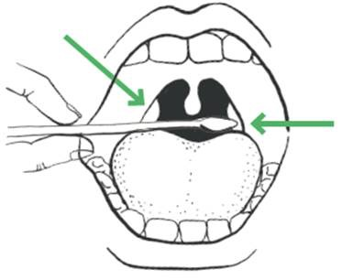

Figure 1 Swab rubbing the tonsil

- The subject should complete hand hygiene using the alcohol based hand rub provided in the booth
- The swab should be removed from sterile packaging by the subject.
  - The swab must be kept dry before taking a sample from the back of the throat and therefore it must not touch any surfaces including the teeth, gums, and tongue or cheek surfaces when conducting the test.
Please note: The swab will be invalid if it touches these parts during or after sampling and it must be put in healthcare (chemical) waste container and a fresh swab selected.
- Holding the swab in their hand, the subject should open their mouth wide and rub the fabric tip of the swab over both tonsils (or where they would have been) at the back of the throat with good contact at least 3 times. Carefully remove the swab stick from the back of the throat taking care to ensure that it does not come into contact with any other structure or surface.
- The subject should then insert the same swab into one nostril. The swab tip should be inserted up to 2.5 cm (1 inch) from the edge of the nostril. Roll the swab 5 times along the mucosa of the inside of the nostril to ensure that both mucus and cells are collected.
- Note: In children, adults and the very elderly where throat swabbing is more difficult or they have a very sensitive gag reflex that prohibits the throat swab from being completed successfully, double mid-turbinate nasal swabbing can be used.
- The subject will be required to place their swab directly into the prepared extraction tube on the bench at the window with the cotton bud end facing down.
  - The subject will not grasp the cotton bud end, which has been in contact with the tonsils and nostril.
- The subject will complete hand hygiene using alcohol based hand rub in the booth. If the operational model includes the subject handling any equipment (e.g. hand mirror) they should disinfect the surfaces with anti-viral wipes
- The subject will put back on their face covering and leave the booth.
In the event that a subject vomits, operations at the testing bay shall be ceased and the site personnel should follow the spillage guidelines until the area has been cleaned adequately to allow resumption.

Sample processing and analysis procedure
The Processing Operative should prepare the area in advance of receiving the sample and barcode from the subject.
The Processing Operative should only process one sample at a time.
The following steps will be followed in line with manufacturer’s IFU and with equipment available:
- The Processing Operative receives barcode directly from the subject (as described in self-swab section above)
- The Processing Operative then removes the LFD device from the pouch and applies a barcode to the underside of the LFD cartridge.
  - LFD cartridges should be used without a long delay after opening the pouches in which they are supplied.
- The Processing Operative sets up the extraction tube by following these steps:
  - Place the extraction tube in the tube rack with the opening facing up
  - Press the extraction solution bottle to drip 6 drops of extraction solution into the extraction tube without touching the edge of the tube. Do not let the buffer bottle touch the edge of the tube. The extraction solution bottle should be decontaminated with anti-viral using wipes between samples to prevent cross-contamination.
    - Manufacturer’s note: guidance should be followed for the 6 drops of extraction solution to be added to the tube. However, results with 4 to 7 drops have been validated and accepted.
  - The extraction tube will be left in the tube rack on the processing bench next to the window for the subject to place the swab
- The Subject will place the swab sample into the prepared extraction tube (as described in self-swab section above) located on the table at the window (to potentially prevent the swab from drying out)
- The Processing Operative then takes the swab and commences the following steps:
  - Extract: Hold and press the swab head against the wall of the tube with force while rotating the swab for about 10 seconds to release the antigen into the extraction solution from the swab head
  - Remove swab: Squeeze the swab head by squeezing the lower end of the tube while removing the swab in order to remove as much liquid as possible from the swab as shown in Figure 2
  - On withdrawal, immediately dispose of the swab into healthcare waste bin.
  - Install a nozzle cap onto the extraction tube
  - Load: drip 2 drops of the sample inside the extraction tube into the sample well of the LFD cartridge
    - Manufacturer’s note: guidance should be followed for the 2 drops of extraction solution to be loaded on the cartridge. However, results with 2 to 4 drops have been validated and accepted.
Record the time of test (Drop @ XX:XX) in marker on the LFD and make sure you have set a timer to read the results at 30 minutes.
  - Re-check that the liquid can be seen seeping through the cartridge (to ensure the drop was not an air bubble)
  - If the cartridge appears dry, the subject will need to be recalled for a further sample to be taken.
  - If needed, move the cartridge to a defined processing space for reading and leave for between 20-30 minutes as below. Please note the LFD movement should be kept to a minimum and where it is required to be moved, keep horizontal using a tray.
- Clean the sample preparation area and equipment thoroughly with disinfectant (e.g. anti-viral wipe)

Figure 2 Extraction buffer preparation

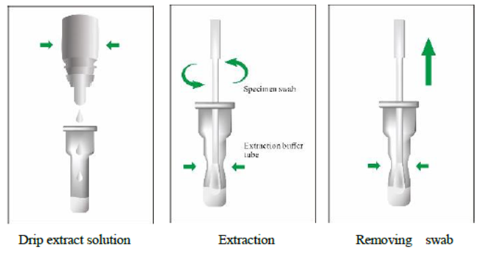
The Processing Operative is responsible for preparing and loading (‘dropping’) the sample onto the cartridge after receiving the subject’s swab.
The subject can leave the test centre and await results communication after loading. The testing site is entitled to set up a waiting area for subject to wait for the results. The waiting area should follow the physical requirements outlined earlier in this document.
The Processing Operative may move the LFD to a different area to read results, keeping movement to a minimum and always keeping it horizontal with a tray. The LFD can be grouped by time cohort.

Reading and interpreting LFD result
- Reading: The result is read by staff according to manufacturer IFU between 20 and 30 minutes
- Results Interpretation:
Strong positive results can be reported at 20 minutes, however, negative results must be reported at 30 minutes.
If a positive signal appears after 30 minutes, it should not be reported as positive. Line C must be coloured to have a valid test result.

Figure 3. Result interpretation
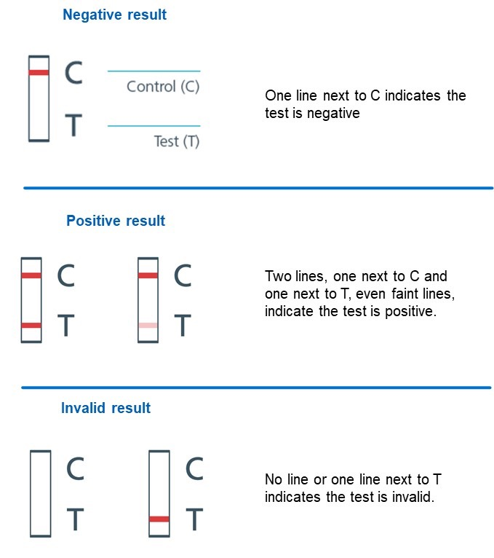

Valid results:

Negative result: There is coloration on line C only, suggesting that there is no SARS-CoV-2 antigen in the specimen.
Positive result: There is coloration, even if faint, on both line C and line T showing as follow pictures, indicating that there is SARS-CoV-2 antigen in the specimen.

Invalid results:

There is no coloration on line C, as shown in Figure 3. The test is invalid or an error in operation occurred.

The operator cannot differentiate whether a T line is discernible or not.

- Tests are marked with a black permanent pen and removed from the desk. A symbol system should be used to avoid confusion:
    - ‘+’ mark for positives – removed any time before 30min
    - ‘V’ mark for invalid – removed 30min after “drop”
    - ’-‘ mark for negatives – removed 30min after "drop"

- The LFD can then be moved to the next station for data logging/result recording
- The area where the device was situated is then cleaned after it has been removed

Recording of results
Results logging using web app (for locally provided devices)
- Sign-up for an account
- Select the test site location
- Scan the LFD barcode as per digital results recording process (Figure 4) with the web based application and digitally record the applicable result
- The area where the device was situated and equipment (i.e. pen, tray, etc.) are then cleaned after each batch anti-viral wipes
- Once result has been logged, the LFD are disposed of as per the requirements outlined in the waste management section (12).
Figure 4. Web app Digital solution that records and captures results
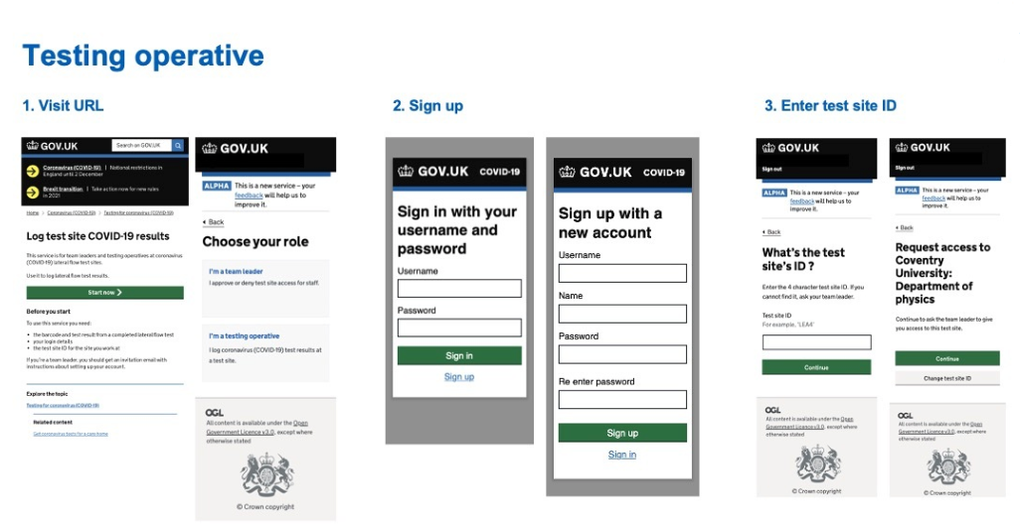
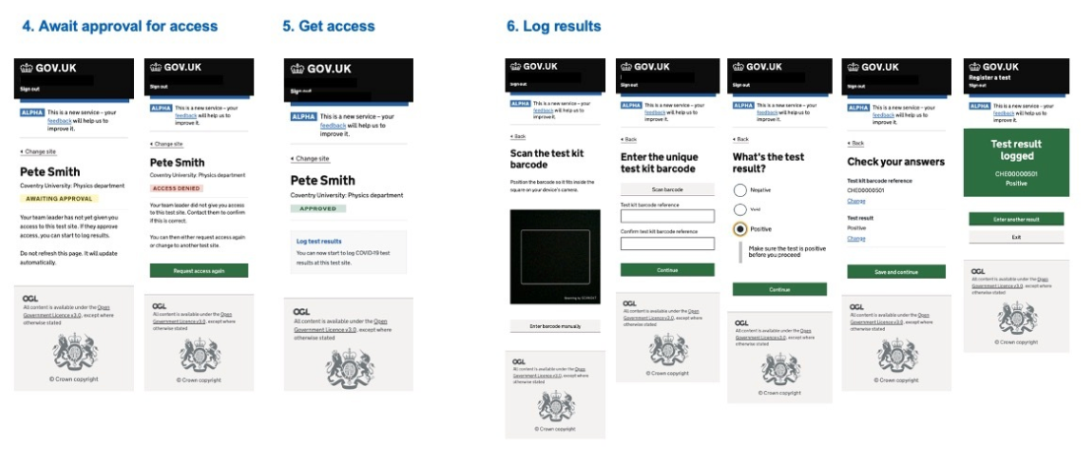
Results logging using iOS app (for DHSC provided managed devices)
- Login to the results application
- Select the test site location
- Scan the LFD barcode as per digital results recording process (Figure 5) with the iOS mobile application and digitally record the applicable result
- The area where the device was situated and equipment (i.e. pen, tray, etc.) are then cleaned after each batch anti-viral wipes
- Once result has been logged, the LFD are disposed of as per the requirements outlined in the waste management section.

Figure 5. iOS Digital solution that records and captures results
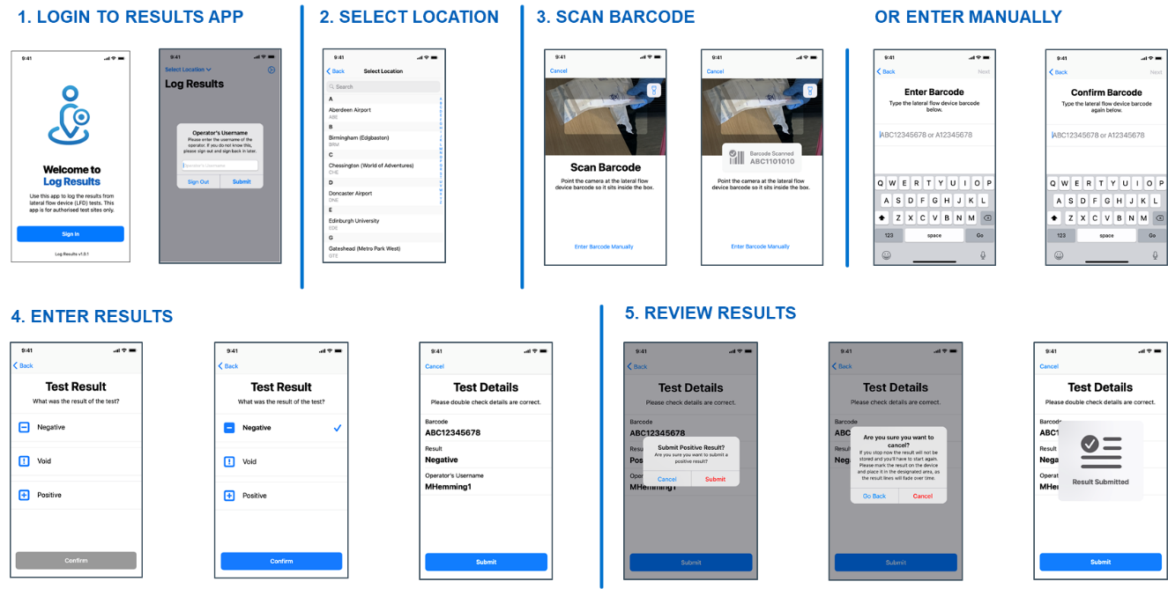

Data Management:
The results are uploaded as linked to the barcode. Hence, there is no visibility or access to linking the results with the subject’s identity.

Communication of results
If giving the result in person (in the context of a pilot), this needs to be delivered using a prepared script, and people will be advised to contact one of the NHS T&T nurses for further advice if necessary. This script should include (but is not limited to):
- Detail of the result (negative, void, positive)
- Instructions on what to do for void results (retest LFD, register for home PCR)
- Instructions on what to for positive results (go home immediately and follow self-isolation guidelines)
- Travel advice for subjects
- How to register for a confirmatory test (where applicable)
The ATS will analyse the sample and upload the test results linked to the barcode to NHS Test & Trace digital system. The ATS is unable to link any results to individuals. The Test & Trace systems will link the registration record with the test result.
Results will be sent to the subjects via text message and/or an e-mail using contact details recorded at the registration or check-in process. The results will be communicated within a day of the test. The wording of the result text will reflect the national guidance published by the NHS.

Reporting
The reporting data flow for antigen testing is as follows:
- NHS BSA (for subject result notification)
- Keystone* (to update GP records)
- NHS Digital
- Public Health Agencies in line with mandatory notifiable disease reporting regulations:
  - Public Health England (PHE)
  - NSS Scotland (on behalf of Public Health Scotland)
  - BSO Northern Ireland (on behalf of Public Health Agency)
  - NWIS (on behalf of Public Health Wales)
- NHS Arden and GEM CSU (on behalf of NHS E/I)
- DHSC Edge (for NHS Test and Trace/Joint Biosecurity Centre)
*Please note that for lateral flow tests at ATS only positive results will be updated into GP records (not negative or void) provided the correct demographic information is provided. This has been agreed with Joint GP IT Committee.
As per the latest amendments to the Health Protection Regulations relating to notifiable diseases reporting, these results need to be reported into the public health bodies in the UK. Test and Trace will undertake this notification through the above data flows for any testing that uses our digital systems, so additional notification is not required unless there are existing relationships between you and your local Health Protection Team.

Negative results
Subjects who return a negative test result do not need to self-isolate unless: a) they are symptomatic (they’ll need to book a different test), b) someone they live with tests positive (or has symptoms and has not been tested yet) or c) they’ve been traced as a contact of someone who tested positive.

Invalid results
Subjects who return an invalid (or could not read sample) LFD result should be offered a follow-up test:
- If the subject is within close proximity of the testing site where they took the first test and it is operationally feasible, it is recommended that they return to the site and take a second LFD test. If the LFD result is invalid a second time, they should be retested with a PCR test. Where this is operational, guidance will need to be provided to the Subject while they are at the test site.
- If the subject has left the testing site and it is operationally more feasible, it is acceptable to retest with a PCR test after the first invalid result. Subjects should be directed to go to www.gov.uk/get-coronavirus-test and choose ‘home testing’ (do not choose a test site).
While awaiting a follow-up test they’ll only need to self-isolate if a) they are symptomatic (they’ll need to book a different test), b) someone they live with tests positive (or has symptoms and has not been tested yet) or c) they’ve been traced as a contact or someone who tested positive.

Positive results
People who return a positive LFD result must take a different follow-up test on the same day (or as soon as possible). They should follow the instructions given to take the follow-up test. If not given instructions at the Test Site, they should go to www.gov.uk/get-coronavirus-test to book a follow-up test on the same day or as soon as possible. They should choose to visit a test site (e.g. RTS/MTU/LTS) if possible, as it is faster than requesting a home test.
The purpose of this policy is to mitigate the impact of false positive results. Without a rapid confirmatory testing result, contact tracing will not be initiated quickly and this will impact on the overall effectiveness of the public health intervention.
Until the subject gets further advice they and everyone in their household must self-isolate immediately for 10 days. The 10 days begin the day after your test date. They should only leave home for their follow-up test.
This policy will be regularly reviewed based on operational systems.
If the employer is taking clinically responsibility it is recommended that they follow the national approach.
Confirmatory testing should also be made available where requested, regardless of positivity. Where a confirmatory test is requested by the subject who received a positive result, this can be done by requesting a home test.

Travel advice for positive results
In the event that a subject tests positive they should be advised to:
- Travel home immediately, wearing a face covering
- Wherever possible they should travel home in their own vehicle or by walking or cycling
- If it is not possible to do so, they should arrange for a member of their household to pick them up
- They should avoid public transit or a taxi service
- If they have no other option they should arrange a taxi to get home preferably equipped with a protective screen between themselves and the driver
- Asymptomatic contacts of positives cases should go home as they would normally do. If the contact becomes symptomatic, they should follow same travel advice as positive cases.
- It is especially important that people follow Government guidance on hygiene, including hand washing before leaving, throughout the process of attending a testing site.

Repeat testing
Current advice is that for most use case scenarios a previous PCR positive test is likely to make testing with an LFD antigen test not necessary. However, as the evidence base regarding this is awaiting full assessment and policy implementation, it is recommended that individuals are informed testing may not be necessary but is still an option. Before implementation, use cases should always consider the public health aims and implications of not testing, e.g. where the aims are in the context of risk reduction, rather than case finding, and are in a high risk setting for potential harm then full testing should still be encouraged. Specific guidance should be sought if there are particular concerns.
If you have recently (within 90 days) tested positive for COVID-19 (and where appropriate had this test confirmed), you are likely to have developed some immunity, and therefore a repeat LFD test is unlikely to be necessary within this period. If having recently tested positive for COVID-19, you choose to have an LFD test as part of this programme, please ensure the LFD test is not taken whilst still within your period of isolation following the last confirmed test. If symptoms [other than cough or a loss of, or change in, your normal sense of taste or smell] persist, this could be longer than the normal 10-day self-isolation period for confirmed cases. This is described in Stay at home: guidance for households with possible or confirmed coronavirus (COVID-19) infection’.

Quality management
[Pilots should update this section appropriately]
An essential element of the programme is that we deliver clinically accurate testing – if the testing procedure is not carried out effectively, an individual who has COVID-19 may incorrectly receive a negative result and not self-isolate. In addition, to protect staff and guests it is essential that PPE provided is worn appropriately and when required hand sanitising techniques are used.

Internal Quality Assurance
Internal Quality Assurance (IQA) is the process to ensure that the processes documented in the quality management system can deliver repeatable results.
An internal quality assurance programme will be run for each use case at selected sites, to ensure they are performing at the appropriate level. This will involve sites running known samples at periodic intervals.
This will be phased over time and will be coordinated by the National Testing Programme who will provide a detailed work instruction to the sites in scope for this process. Further guidance will be provided on the timing and scope of this process.

On-going programme-level evaluation
Dual swabbing at a selection of sites (determined through the development of use case archetypes) will be enacted for the purpose of ongoing evaluation. Analysis will be performed at an aggregate level for the archetype as a whole, and not for individual sites. This will be coordinated centrally by the National Testing Programme who will provide a detailed work instruction to the sites in scope for this process.

Site level quality management plan
Each pilot and use case team is responsible for creating a quality management plan prior to the start of the pilot, which may include the following:
Training:
- Knowledge assessment at the end of on-line training
- Face-to-face training by trained supervisor during mobilisation or first day
- Staff competence and training checks
Observing testing process:
- Daily/weekly clinical governance audits by site supervisor checking:
  - Subjects understand self-swab procedures and are performing correctly
  - All testing staff have appropriate training
  - Onsite testing supervision: Observing the end-to-end testing process of a sample of tests to ensure that knowledge and skills are appropriate
  - Taking off and putting on PPE and hand washing is within guidelines
  - Supplies and equipment are being stored and handled correctly
  - Waste is segregated and managed correctly
- A clinical governance record should be used to document that the checks have been undertaken and that if any actions are necessary that they are documented and followed up in a timely manner
- Where interventions do not improve with further training/guidance, the staff should be removed from performing clinical tasks
Monitoring results/KPIs:
- Void rates and invalid tests
- Rates of discordant results where confirmatory testing is in place
- Random sample of dual tests where a number of lateral-flow tests require a complementary PCR test, where the PCR is only for QA purposes and the results are tracked and compared against LFD results. Training for personnel performing the QA process will have been carried out in advance.
- Studies evaluating false negative and false positive results
- Void and positive rates comparison with other sites to detect anomalies or trends
- Operator-specific audit trail
- Reporting errors
- Serious incidents monitoring
- Risk and mitigation plans
- Quality control checks of the test-kit (conducted at a central laboratory on batches of test kits before dispatch

Accountability
As a part of the test facility workforce, as outlined in this document, each site will be required to designate a member of the team to act as Quality and Governance Lead (or Testing Supervisor) who will have accountability for the clinical quality and risk management of the service within the context of a non-laboratory environment. This person will undertake the following:
- Implement appropriate quality assurance
- Implement a quality & safety incident and risk reporting system
- Support the site manager in maintaining site risk register, develop and implement mitigation plans
- Report on quality assurance, incidents, risks and mitigations.
- Review testing staff training records and undertake testing staff performance reviews
- Ensure the promotion of good quality practice across the service delivery
- Undertake quality audits
Where private providers are assuming clinical responsibility for the testing, they will also be responsible for quality assurance component.

- PPE
Staff on sites are required to wear the appropriate PPE for their role as detailed below (refer to Section on Key stakeholders for the definition of roles):

Role | Disposable gloves | Disposable plastic apron | Fluid-resistant (Type IIR) surgical mask (FRSM) | Eye protection
Processing Operative² | ✓ | ✓ | ✓ | ✓
Indicates single or sessional use | Replace after each test (single) | Replace after each session | Replace after each session | Replace after each session
Cleaning Staff³ | ✓ | ✓ | ✓ | ✓
Test Assistant⁴ | × | × | ✓ | ×
Site Coordinator / Team Leader | × | × | ✓ | ×
Registration Assistant | × | × | ✓ | ×
Results Recorder⁵ | × | × | ✓ | ×
Supplies Coordinator | × | × | ✓ | ×
Queue Coordinator | × | × | ✓ | ×
Indicates single or sessional use | Replace after each session | Replace after each session | Replace after each session | Replace after each session

Notes:
- Anything not identified as “single use” is for “sessional” use (a session ends when a worker leaves the care setting, fresh PPE is used at the start of each session) i.e. at break or end of shift. PPE is sessional however should be changed if protective properties are compromised or contaminated from secretions.
- Processing Operatives should wear apron/visor and mask sessionally and change gloves between samples.
- Cleaners need to change gloves and apron if cleaning a spillage
- In this SOP the Test Assistant is not administering the swab and is only supervising, therefore Test Assistants do not need to wear apron, gloves and visor, but they need immediate access to gloves if intervening
- Results recorders are not expected to be handling the LFD cartridge. If required to intervene and handle devices they should have gloves available as an exception and take off and dispose of gloves after completing the activity or task
PPE should be changed between sessions for all staff except those who assist an individual in taking a test; Test Assistant staff must change their PPE in-between individuals whom they assist / intervention is required.
PPE should be changed if protective properties are compromised or if contaminated, or if suspected to be contaminated.
Cleaners should only be entering the testing area when testing activity is no longer being conducted. In accordance with NHS guidance ‘Cleaning and Disinfection process COVID -19” there should be no subject contact within 2m and fluid resistant surgical masks type IIR are to be worn in all non COVID secure areas by cleaning staff.
Staff who are required to top up supplies within test areas should do so at the beginning of each testing group and when no subjects are present.
All staff need to be reminded of the importance of IPC guidance. Regular handwashing and consistent social distancing are key to ensuring safety for all roles.
This is enabled and supported by frequent cleaning of test booths and high touchpoint areas.
Protocols for putting on and taking off PPE can be found below in the Appendix of this document.
- Supply & Equipment
DHSC support team will provide sample collection kits and lateral flow antigen test devices to the employer or host organisation. At DHSC’s discretion, DHSC may provide the organisation with materials and resources to enable pilot activities, including but not limited to PPE and hygiene products.

DHSC will provide:
- Sample collection kits (all types)
- Lateral flow devices (all types)

The organisation will take responsibility for managing, tracking and ordering all other equipment required for the set-up and day to day running of a test site, including but not limited to:
- PPE (including gloves, aprons, masks, goggles/visors)
- Medical consumables (including cleaning agent, tissues)
- Physical infrastructure including toilets
- Signage
- Consumables (non-medical) (including catering)
- Safety (can include fire extinguishers, defibrillator)
- Healthcare waste (including bins, bags, containers)
- General waste (including bins, bags, containers)
- Miscellaneous (including mobile devices, scanning devices, whiteboards, printers, tools)

Note: A detailed list of all the entire site inventory will be made available to the organisation
- Data Management

Data control
Within the scope of the process outlined in Testing Process section, employers and host institutions are not regarded as Data Controllers or Processors.

The Department of Health and Social Care (DHSC) is the data controller for all sites. All other partners will be classified as data processors acting under the instruction of DHSC if they are required to store personally identifiable information on their subjects. As processors of data, the site must have a process in place for ensuring that data protection legislation is complied with. Controls include (not an exhaustive list):
- A single point of accountability for subject data
- Processes to ensure subject data is not lost (security)
- Processes to ensure subject data is destroyed when it is no longer needed by the site (storage limitation)
- Processes to ensure that subject data is only used for its intended purpose (purpose limitation)
- Processes to ensure that data collected is limited to that needed for its intended purpose (data minimisation)

Consent from the data subject
The organisation is responsible for communicating the purpose of the testing to develop an understanding of the service. Participation by the subject is voluntary.

If an employer or host institution is classified as a data processor or controller, they must issue a data privacy notice that informs the subject of how their data will be used. If the subject wishes to participate, having now received this information, the subject will issue their consent. The organisation is responsible for capturing consent. The organisation must store a copy of the subject’s consent for the duration of the pilot.

How subject data is captured and shared with DHSC
The following data elements are captured by the Registration process, a service that is operated by DHSC and NHS Digital:
- Whether the test is being taken at a test site or at home
- [If at a test site] The postcode of where the test is being taken
- [If at a test site] The test site the test will be taken at
- Test kit URN (barcode of test kit)
- The date and time that test will be taken
- Subject date of birth
- Subject name
- Subject gender
- Subject ethnic group
- Subject ethnic background
- Whether the subject is displaying any coronavirus symptoms
- The country the subject lives in (Member of the UK)
- Subject home postcode
- Subject address line 1
- Work OR Study Status – plus Industry, Occupation, Employer OR Study Grade, Institution, Institution Town
- Whether the subject has an email address and, if so, what that address is
- Whether the subject has a mobile phone number and, if so, what that number is
- Whether the subject has a landline phone number and, if so, what that number is
- Whether the subject knows their NHS number and, if so, what it is

- Appendix A: Infection Prevention and Control (IPC)

General guidance
No subjects should attend the testing location with symptoms of COVID-19. The on-boarding operative will ensure eligibility as per section: Subject eligibility.

Any non-compliance will be escalated through existing organisation incident management protocols. Those on-boarding operatives who may be exposed to these individuals will be provided with IPC advice based on government guidance for managing a Subject with possible COVID-19: https://www.gov.uk/government/publications/wuhan-novel-coronavirus-infection-prevention-and-control

All workers on site must be fully briefed and trained about PPE and IPC standards, including those approved by the NHSE/I IPC Cell. Guidance of IPC standards must be clearly displayed at all sites. All staff members are encouraged to not neglect the importance of hand hygiene, not to touch their face whilst working with samples, and importantly stay at home if they develop COVID-19 related symptoms.

Testing procedures incorporate IPC guidance, to prevent potential contamination of staff members and subjects whilst operating the testing site.

On-boarding operative staff will focus on maintaining social distancing when communicating with subjects.

A summary of the key elements to support IPC can be seen below, and all sites will display appropriate signage, including:
- Hand washing
- Respiratory hygiene - ‘Catch it, bin it, kill it’
- Personal Protective Equipment (PPE) (Donning and Doffing)
- Social distancing: All workers should always remain 2 metres apart where possible, in accordance with government guidance
- Equipment distancing and cleaning
- Effective segregation and disposal of waste

Cleaning policy
Regular cleaning plays a vital role in limiting the transmission of COVID-19. It is important to reduce the clutter and remove difficult items to clean, the frequency of cleaning should be increased paying particular attention to surfaces that have been touch frequently. The frequencies of the frequent clean is dependent on the number of people using the space, whether they are entering and exiting the setting and access to hand hygiene i.e. hand washing or use of an alcohol-based hand rub. As a minimum frequently touched surfaces should be cleaned twice a day, and one of these should be at the beginning or the end of the working day.
Public areas where a symptomatic subject has passed through and spent minimal time but which are not visibly contaminated with body fluids can be cleaned thoroughly as normal.
Cleaning staff must follow the PPE guidance as listed. They should only enter sampling areas when the activity is no longer being conducted. In case of a spillage when they need to enter an active test area, cleaners should ensure that they have appropriate PPE, avoid Subject contact within 2 meters and change their PPE after cleaning.
In view of the minimal level of spillage expected, the following cleaning guidelines must be respected:
- All surfaces that the Subject has come into contact with must be cleaned and disinfected, including all potentially contaminated and frequently touched areas such as handles, light switches, telephones, and the surfaces that the subject may have had contact in between each individual that is tested
- Use disposable cloths or paper roll and disposable mop heads, to clean all hard surfaces, floors, chairs, door handles and sanitary fittings – think one site, one wipe, in one direction and place in the offensive waste bin (tiger bag)
- Any cloth and mop heads used for cleaning must be disposed of and should be placed into the offensive (tiger bag) waste bin provided
- Surfaces will require to be cleaned at the end of the session before the next session starts i.e. in between test group batches of Subjects
Use one of the options below:
- A combined detergent and disinfectant at a dilution of 1000 parts per million (ppm) available chlorine (ppm av.cl)

- A household detergent followed by disinfection (1000 ppm av.cl). Follow manufacturer’s instructions for dilution, application and contract times for all detergents and disinfectants

- If an alternative disinfectant is used within the organisation ensure that it is effective against enveloped viruses
Avoid mixing cleaning products together as this can create toxic fumes. Avoid creating splashes and spray when cleaning.
Any cloths and mop heads used must be disposed of and should be put into the offensive waste stream (tiger bag) as outlined in this document
The minimum specifications stipulated by the government for surface disinfectant wipes, is that the disinfectant is effective against envelop viruses. It is recommended were possible that combined detergent and disinfectant wipes is used, as they will both clean and sanitise the surface at the same time.
If a disinfectant wipes are used, it is important to note that they do not contain a detergent. If this method is used, it is important that the area is cleaned properly with a detergent, rinse before a disinfectant wipe is used.
For all wipes it is important that the manufactures instructions are following in relation to the contact time required. It is advisable where possible to purchase packets that have a reliable closure mechanism to ensure wipes do not dry out between uses, as this will affect their ability to be effective against the virus.
Efficacy testing standards:
Bactericidal activity (antimicrobial) | EN 1276, EN14348, EN 13727, EN1040, EN1499
Fungicidal / yeasticidal activity | EN 1650, EN 13624
Virucidal activity | EN 14476

Labelling Requirements
- Brand name
- Product Description
- Disposal method warning
- Quantity of wipes
- Safety Precautions
- BS EN number to which the products conforms
- Manufacturer details
- Single Use (indicated with a symbol of a 2 in a circle with a line through it)
- CE Mark
- LOT number
- Expiry date (this is often indicated with a symbol of an egg time)
- Table with contact times required to achieve sanitation against specific microorganisms (not a specific requirement, but very useful information)

Hand sanitisation
It is critical for Test Sites to ensure that guests and staff are maintaining regular hand sanitisation as prescribed in this document and the testing procedures. Testing booths or sample collection areas should be equipped with hand sanitiser dispensers for use throughout the testing process. In accordance with guidance from the WHO 2020 – effective alcohol-based hand rub products should contain between 60% - 80% of alcohol and its efficacy should be proven according to EN1500.
- Appendix B: Waste Management
[Pilots should update this section appropriately if they have been given specific waste management advice for their particular setting or application]
Please note that this guidance will need to be reviewed by the relevant agencies in Devolved Administrations for local application as they may require specific changes to be made to align with their regulations.

Classification
While the testing sites are regarded as healthcare settings in England and Wales, in Scotland they are viewed as municipal sites. In either scenario the waste that is generated should be segregated at source and should not be over classified as clinical waste. With the increased testing availability in the National Testing Programme, there is a requirement to fully understand the responsibilities of healthcare waste management at a local level. Investigation is on-going in Northern Ireland.
All areas have a waste management ‘Duty of Care’ and are responsible for undertaking a local WM3 assessment for the classification of the waste that they will generate (if not identified in the table below), this assessment must be documented. A Duty of Care Waste Transfer Note must be completed before waste is removed from site and records kept for minimum of 2 years were applicable.

Regulatory Position Statement C23
The Environment Agency has published RPS C23 Incinerating specified healthcare wastes at a municipal waste incinerator: which can provide an option of disposing of these mass testing wastes via municipal waste incinerators in England, even if the incinerator operator does not have the appropriate waste codes on the permit.

Prior to a new site being set up
Prior to setting up any new testing site, the waste management chain including the final of disposal should be identified in advance with the Local Authority (LA) and/or the Waste Contractor who is involved in the collection of the waste from the testing site. This will ensure that a plan is in place for the transfer of the waste to final disposal in the safety and most effective manner.

For testing sites where the testing kit waste is classified as 18 01 04 and 18 01 07, the Operational Teams need to consider the following:
- What EFW/Municipal incinerators area available in the location that will accept 18 01 04 and 18 01 07 waste or if there is available capacity outside of the location how will the waste be transported in order to be safely received?
- Where there is no facility already permitted to incinerate 18 01 04 and 18 01 047 wastes and reliance on the RPS C23 may be required contact the incinerator operator to confirm that they will accept the waste and in what form it needs to be delivered
- Where incinerator operators are willing to accept the waste ensure that the obtain permission from the local Environmental Agency Officer and demonstrate that they can meet the conditions set out in the RPS
- Once they have confirmed that permission is in place, arrange a disposal collection schedule

Waste produced from testing sites
- General waste, including takeaway food packaging
- Packaging, including cardboard boxes, plastic bags, information leaflets
- Personal protective equipment, including face masks, visor/goggles, gloves, plastic aprons and gowns
- Testing kits, including testing swabs and packaging, cartridge, pipette, buffer solution, testing strip packaging
Waste is disposed of according to agreed protocol with respect to the respective waste stream described in the following tables (differentiating healthcare and non-healthcare waste).

Transportation category
The waste generated (healthcare waste/offensive) from the testing sites fall outside the scope of Carriage of Dangerous Goods Regulations, ADR, RID and IMDG for road and rail, as well as sea if using ferry routes and would not require an ADR driver (waste is not transported as Category B waste)

Waste bags
Supplies of appropriate healthcare disposal bags and/or containers need to be available to ensure that wastes are not confused at the point of collection, it is therefore suggested:
- Clear or white without biohazard markings
- Yellow, ensuring no hazardous waste (infectious) markings
- Yellow bag with a black strip (tiger bag)

Storage: 72 hours storage and reclassification is not acceptable
Double bagging and allowing a 72 hour holding period in a secure place, prior to the waste being disposed of in the household waste is only applicable to household produced waste and is not fit for purpose approach for the disposal of waste generated at test sites, including mass testing.
There are two models for the correct removal of healthcare waste which can be followed:
- Local Authorities (LA) have the option to use pre-existing waste contracts that may utilise the COVID-19 RPS C23 regulatory position. The regulatory position allows waste management companies to dispose of COVID-19 Lateral Flow Devices (LFD) testing waste in a municipal waste incinerator without having to make permanent changes to their environmental permits, however, there will need to be a Local Enforcement Position issued by the local Environment Agency Office.

- Using Crown Commercial Services, contracts can be established with Speedy, who are a national company and can provide healthcare waste management products, including safe and compliant disposal. Due to the number of demands on the company throughout this time, this should be the last viable option. Speedy can be contacted direct on 01332850004 or at covidsupplies@speedyservices.com
Please be aware that it is not acceptable to store chemical healthcare or offensive waste for a prolonged period of time e.g. 72 hours and then dispose of via municipal route. Waste in these categories must be treated in accordance with the instructions below.

Waste streams for Asymptomatic Testing Site - Lateral Flow Testing
Asymptomatic Testing Site (ATS) using Lateral Flow Testing (LFT), this includes mass community testing, Universities, Schools, Industry, Social Care Homes (adults – Residential Care) including visitors, staff and resident testing))
Item | Sample | Waste categorisation | European Waste Code (EWC) | Likely Management Route / Waste Hierarchy | Health Technical Memoranda (HTM) 07.01 Packaging
General Waste | Sandwich wrapper | Domestic/  recycling | 20 03 01 | 1st Option: Materials Recovery Facility  2nd Option: Energy from waste  3rd Option: Landfill | Not applicable
All packaging | Outer packaging on equipment | Domestic / recycling | 15 01 01  15 01 02  15 01 05  15 01 06 | 1st Option: Materials Recovery Facility  2nd Option: Energy From Waste  3rd Option: Landfill | Use existing municipal route
Swabs | Absorbent pads  Vials  Tissues | Chemical | 18 01 07  Plus  18 01 04 | 1st Option: Municipal Incineration  2nd Option: Clinical Waste Incinerator | 1st Option: Unmarked yellow neutral container/bag  2nd Option: White / clear container/bag  3rd Option: Tiger bag  Do not use hazardous waste packaging
Cartridges / Devices | LFT cartridge | Chemical | 18 01 07  Plus  18 01 04 | 1st Option: Municipal Incineration  2nd Option: Clinical Waste Incinerator | 1st Option: Unmarked yellow neutral container/bag  2nd Option: White / clear container/bag  3rd Option: Tiger bag  Do not use hazardous waste packaging
Personal Protective Equipment | Apron  Face mask  Gloves | Offensive | 18 01 04 | Municipal Incineration or last resort Landfill | 1st Option: Tiger bag

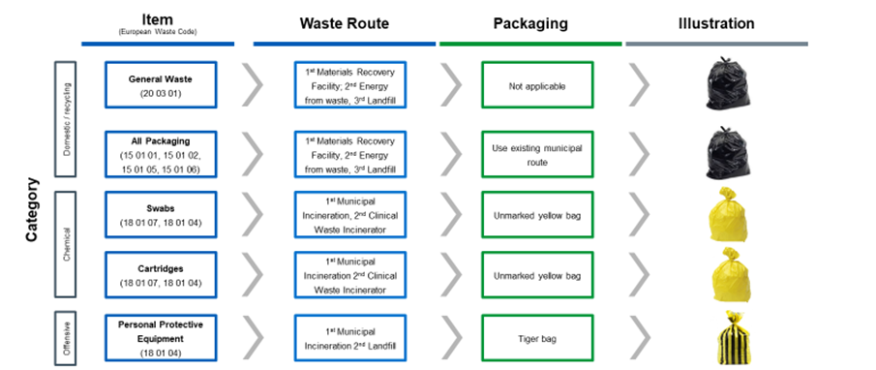

- Appendix C: Site Layout
[Pilots should update this section appropriately detailing their proposed layout, highlighting material deviations]
There are two main design options for Test Site layout depending on the space available and the desired throughput. These designs are being continually refined based on feedback from pilots and final designs will be subject to NHS IPC Cell review.

Booth layout
Features of the booth layout include:
- Useful if test site space is limited
- Offers privacy for testing (requires walls or screens to be set up to create booths)
- A booth with accessible access may be required, which has larger dimensions than a standard booth
- Low throughput: Small or mid-size room suitable for the construction of a single or several booths
- High throughput: Conference room or large open area for the construction of multiple booths

Single booth layout
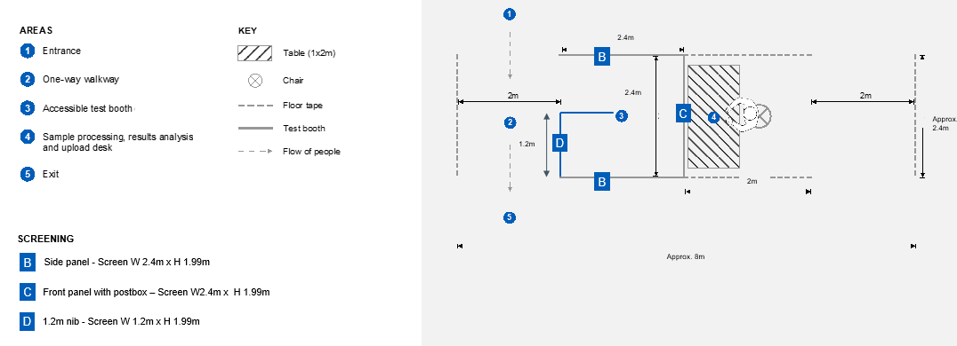

Multi-booth layout

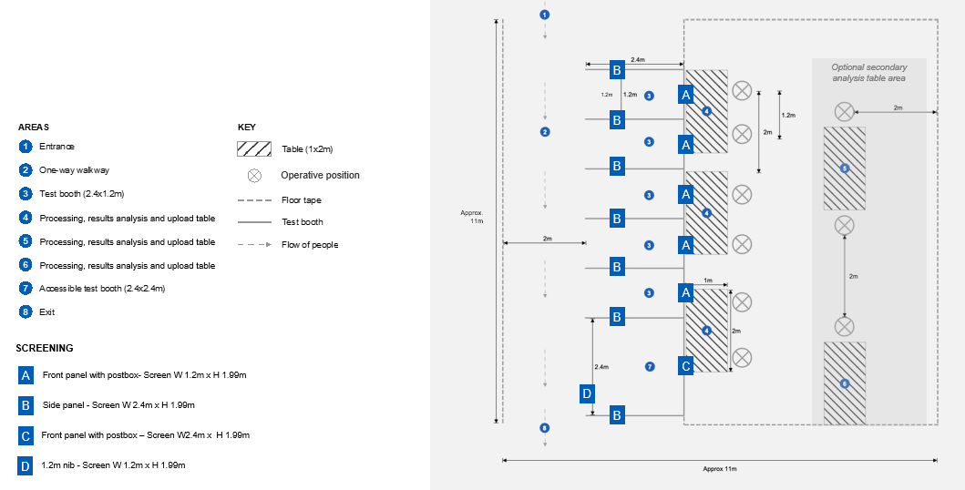

Booth layout: further requirements
Along the front panel of the booth, there will be a clear screen and a 'hatch. It is recommended that the front panel adhere to the following criteria:
- The opening on the front panel must be wide enough for the subject to pass a 15cm long swab through to the Processing Operative without touching the sides. Ideally the opening is 200mm in height and 300mm wide.
- A ledge is required that is perpendicular to the hatch, that must be large enough for a subject to place a swab, bar codes, tissue and other supporting equipment e.g. scissors. The minimum depth is 200mm
- The clear screen should be large enough so that it is reasonable for the Processing Operative and subject to maintain clear line of sight
- Proposed dimensions of the front panel are:
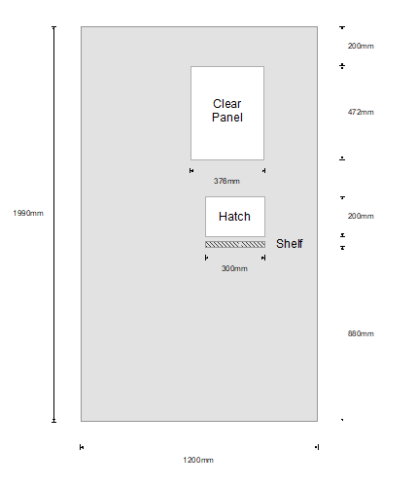
The booth materials (all sides) need to be made with a material that can withstand cleaning using an agent that is 1,000ppm chlorine.

Open plan layout
Features of the booth layout include:
- Single or multi-table layout in an open plan space
- Requires more space than a booth layout due to social distancing requirements
- Suitable for single room/office space, or large test site area that can be demarcated with tape
- Low throughput: Small room for single test and analysis table
- High throughput: Large open test area for multiple tables

Single open plan layout

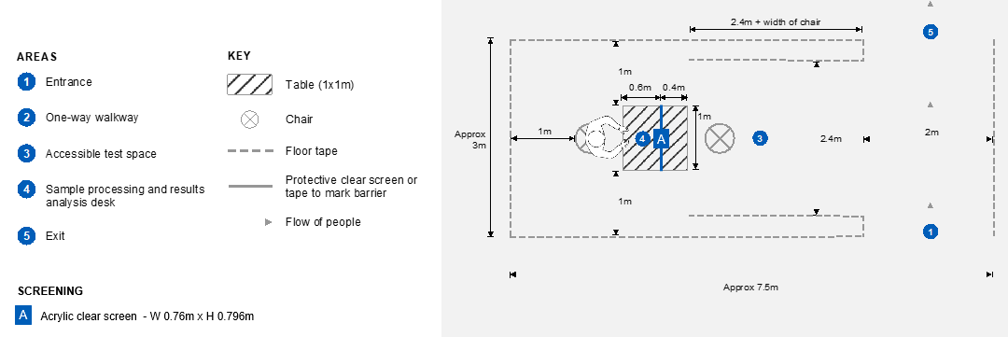

Multi-open plan layout

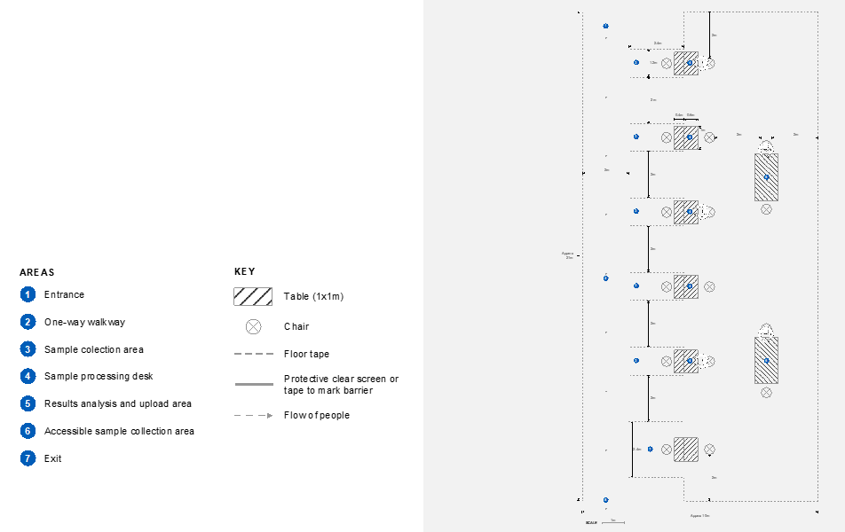

Multi-open plan layout with partitions

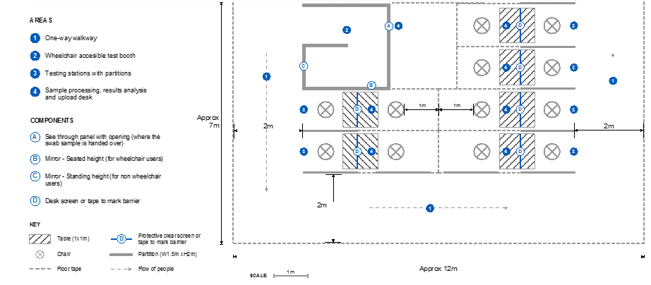

Open plan: further requirements
The open plan option, contains an acrylic screen that is affixed to the table. It is recommended that the equipment adhere to the following criteria:
- Stand must be stable with no wobble with a device to affix to the table so that it is sturdy
- All sharp edges to be deburred/finished to prevent risk of injury
- The booth materials (all sides) need to be made with a material that can withstand cleaning using an agent that is 1,000ppm chlorine.
- Proposed dimensions of the front panel are:

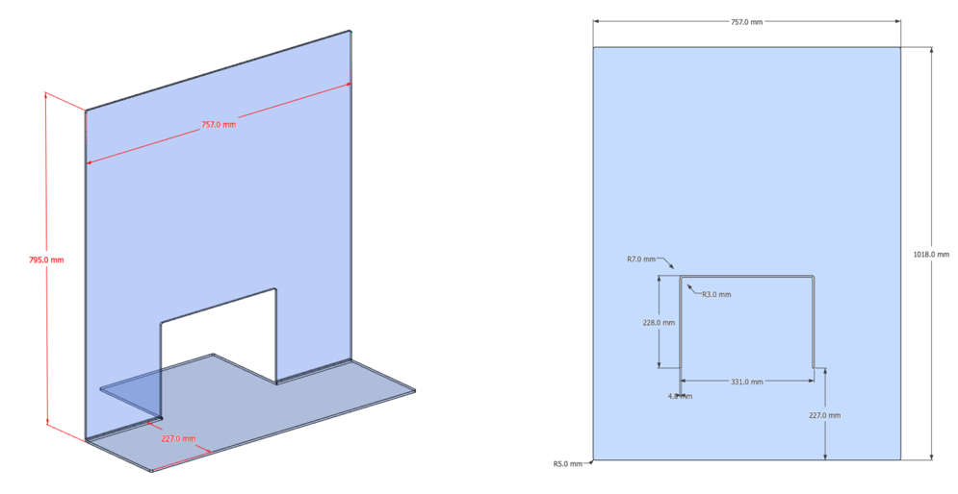

Organisations to build their own site
There is also an alternative for organisations to build their own sites provided that they meet the minimum clinical requirements outlines in this document. Features of the site:
- Have enough space to allow the employee test group to maintain social distancing (as per government guidelines, before, during and after the test
- Have one-way systems to manage the flow of people
- Be accessible to all test participants take account of the provisions of the Building Regulations (including Approved Document M - ‘Access to and use of buildings’) and the Equality Act 2010
- Have hard, non-porous flooring that can withstand chlorine cleaning agents
- Natural airflow is recommended for test site staff and participant comfort
- Have access to hand hygiene (soap and water/appropriate alcohol-based hand rub)

- Appendix D: Self-swabbing Instructions
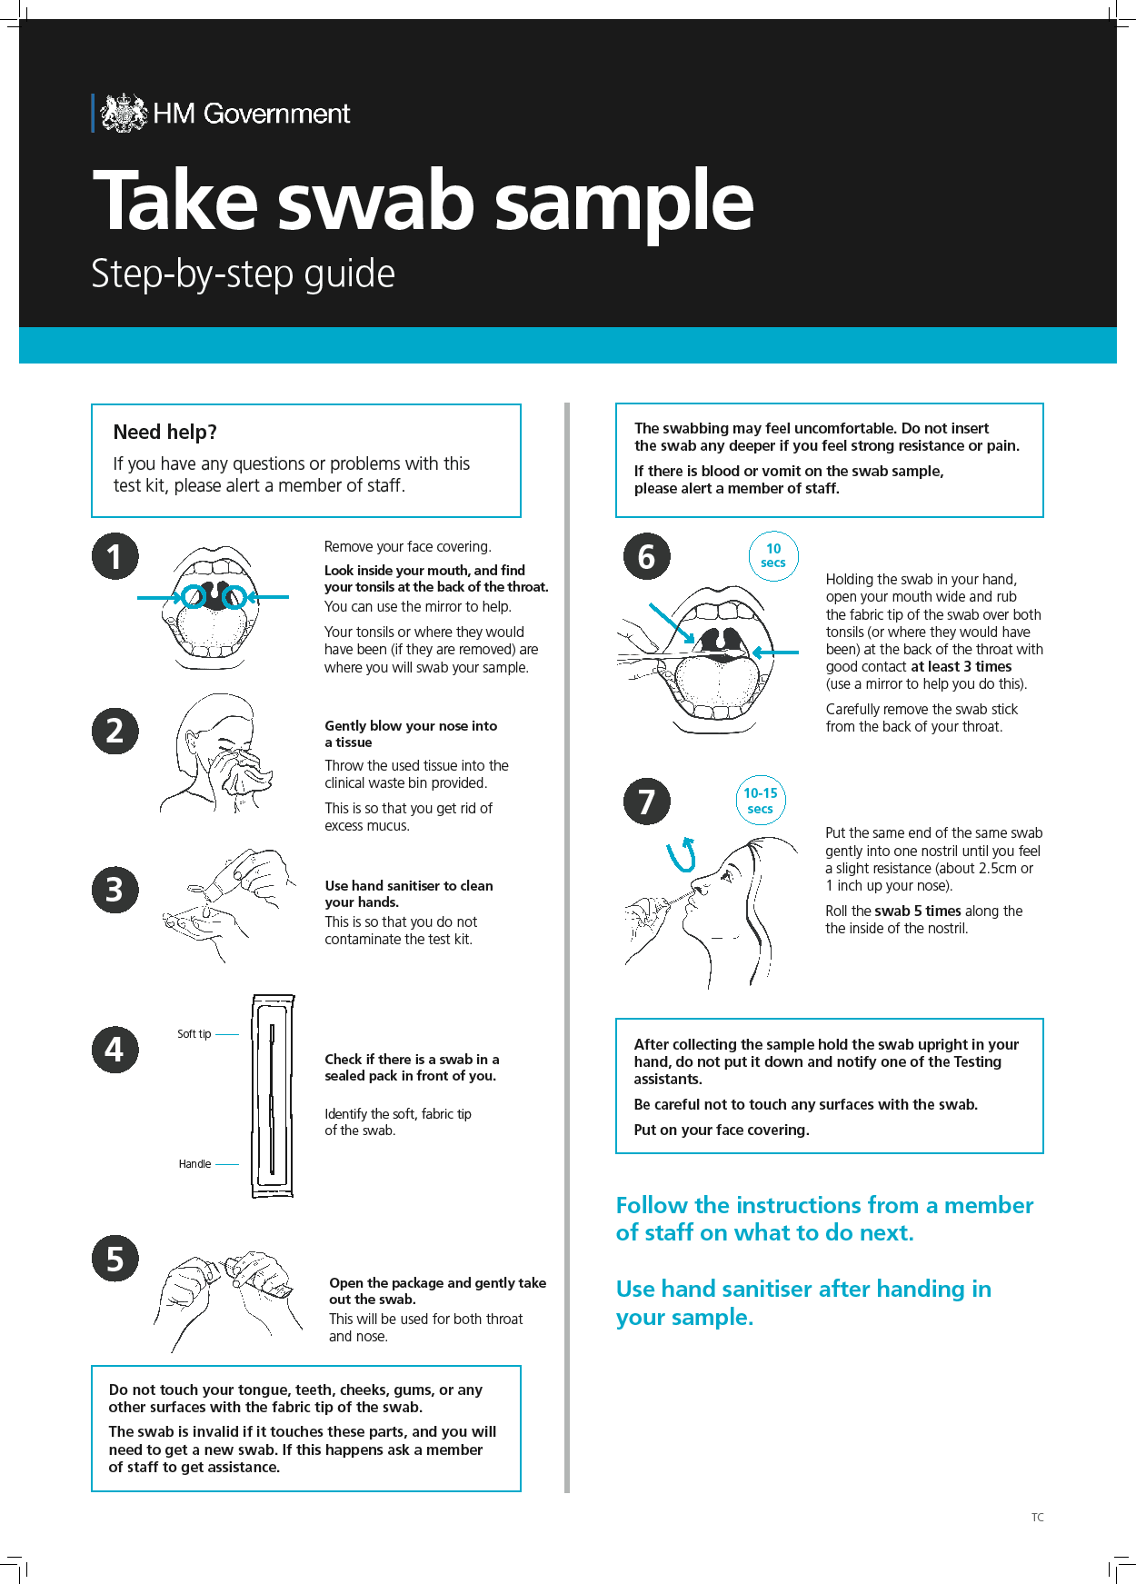

- Appendix E: PPE instructions – putting on and taking off
