Dear Colleagues,
A few notes to help you get set up to see bookings on the Schedulista website for the Covid Screening Programme.

STEP 1.
A user name is set up for you and a link to choose a password comes from

No-reply@schedulista.com
Example below

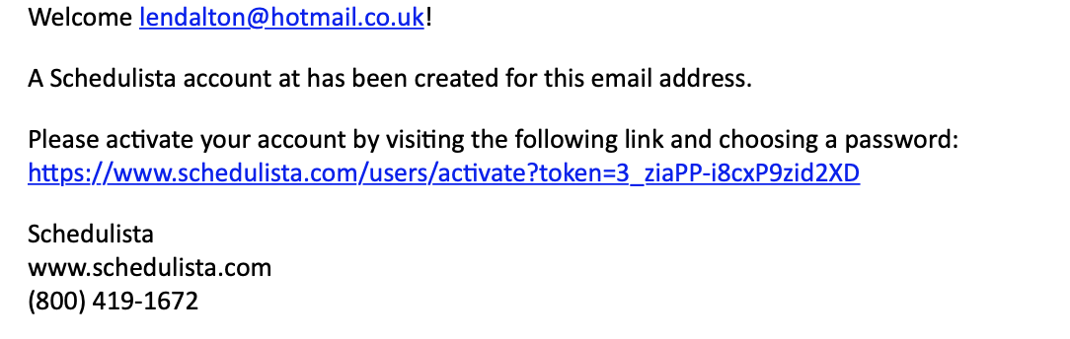

STEP 2
Once you have followed the link and set up a password you get the following acknowledgement

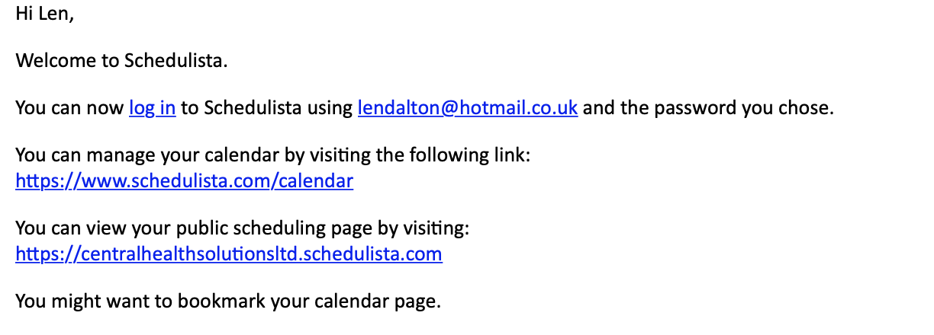

STEP 3

Once you log back in to calendar you can see any appointments made with you. A confirmation for each appointment will come through to your nominated email address.

To amend your opening hours for bookings, click on the settings button while in your calendar. 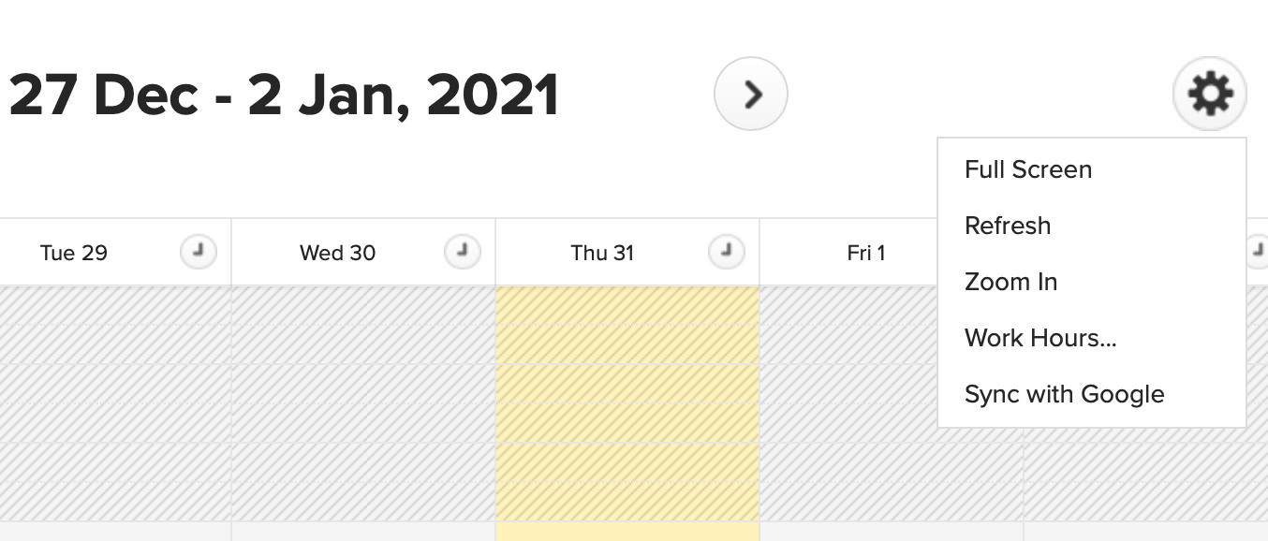

Highlight your work hours and change them to suit yourself in terms of when you want to offer appointments.

Once you have completed and saved your work hours you can also block out periods in the day when you are closed or do not wish to offer appointments.

To do this click on a time on the calendar when you do not want the service and create a “personal appointment”.

You will see that you can also put in appointments for the screening service- however this is best done through the link from the website so that all the relevant information is collated for the Pharmoutcomes submission:

https://www.1centralhealth.co.uk/stokelft

You can cancel appointments but make sure you put in a polite reason for cancelling as the public will see you have cancelled the appointment and the reason why.

Good Luck with the service.

